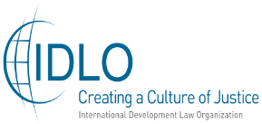
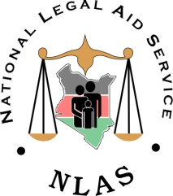
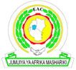

1STEAST AFRICAN REGIONAL LEGAL AID CONFERENCE

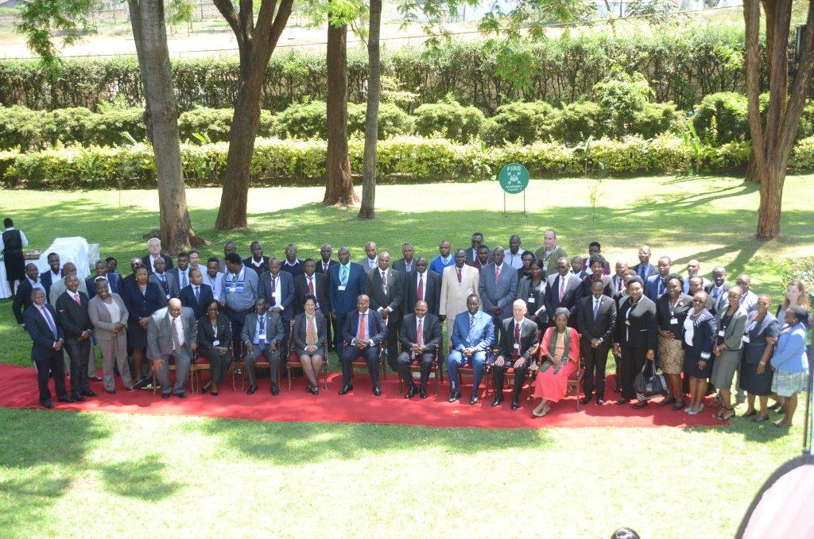

Conference Theme:
“Promoting Access to Justice through State-Funded Legal Aid Schemes: Building Platforms for the Engagement of Legal Aid Networks and the Formal Justice Systems”

November 5th – 8th2018

Safari Park Hotel
Nairobi, Kenya

Conference Report

TABLE OF CONTENTS

List of Acronyms 4
1.1 Acknowledgements 6
Executive Summary 7
1. Background 9
1.1 Introduction, Rationale and Justification 9
2 Aims and Objectives of the Conference 9
3 Outputs and Outcomes 10
3.1 Outputs 10
3.1 Outcomes 11
4. Methodology 11
5. Conference Proceedings 11
5.1 DAY 1 – MONDAY, 5TH NOVEMBER 2018 11
5.1.1 Opening Session 11
5.1.2 Key Note Address 13
5.2 Overview of the Program 13
6. Emerging Themes and Issues 14
6.1 Introduction 14
6.2 Experience Sharing By Legal Aid Organizations: Lessons Learnt, Challenges and Good Practices from the East African Region 15
6.2 Burundi 16
6.3 Kenya 17
6.4 Rwanda 19
6.5 Tanzania 20
6.6 Uganda 21
6.8 Plenary Session 22
7. Experience Sharing by Legal Aid Organizations: Lessons Learnt 23
7.1 Challenges and Good Practices from other Regions 23
7.1.1 South Africa 23
7.1.2 Malawi 24
7.1.3 Kenya 24
7.1.4 Vanuatu – Lessons from the South Pacific 25
7.2 Strategies to Overcome Challenges in the Implementation of Legal Aid Service Delivery 26
7.2.1 Legislative, Institutional and Administrative Frameworks 26
7.2.2 Funding Arrangements 29
7.2.3 Plenary Session 30
7.2.4 Conclusion of Day One 32
8. DAY 2: TUESDAY, 6TH NOVEMBER 2018 36
8.1 Introduction 36
8.2 Promoting Effective and Quality Legal Aid Service Delivery: Perspectives from State and Non-State Agencies 36
8.3 Legal Aid in the Context of Vulnerable and Special Interest Groups – Challenges and Opportunities 38
8.4 Presentation of the Kenya National Legal Aid Network Needs Assessment Tool 40
8.5 Innovations in Legal Aid Delivery and Sustainability 40
8.6 Focus Group Discussion - Mapping the Way Forward Toward the East Africa Regional Legal Aid Network 44
9. DAY 3: 7TH NOVEMBER, 2018 45
9.1 Introduction 45
9.2 The Role of Legal Aid in Access to Justice 45
9.3 Comparative and Institutional Frameworks for Legal Aid 46
9.4 Judiciary’s Experience with Legal Aid 49
9.5 Experiences on Informal Justice Systems in dispensing justice 51
10. DAY 4: 8TH NOVEMBER 2018 53
10.1 Introduction 54
10.2 Recontextualising Legal Aid and Access to Justice 54
10.3 Understanding the Role and Challenges of Legal Aid Networks in Accessing Justice at the Regional Level 55
10.4 Building Linkages for Effective Legal Aid Delivery: the Role of State and Non-State Agencies 55
10.5 Closing Session, Conference Resolutions and Recommendations 56
10.6 Conference Resolutions and Recommendations 57
11. Annexure 61

List of Acronyms

ACHPR African Court on Human and Peoples Rights
ADR Alternative Dispute Resolution
AJS Alternative Justice System
AIDS Acquired Human Immunodeficiency Syndrome
CRADLE Child Rights Advisory and Legal Aid Centre
CSO’s Civil Society Organisations
DFID Department for International Development
DNA Deoxyribonucleic Acid
EAC East African Community
EAJEC East African Judicial Committee on Education
EMCOP Empowerment through the Law of the Common People
EU European Union
FIDA Federation of Women Lawyers
GJLOS Governance, Justice, Law and Order
HIV Human Immunodeficiency Virus
ICJ International Commission of Jurist
ICT Information Communication Technology
ILPD Institute of Legal Practice and Development
IT Information Technology
IVR Interactive Video Recording
IDLO International Development Law Organisation
JTI Judicial Training Institute
KNCHR Kenya National Commission on Human Rights
LAPSNET Legal Aid Providers Support Network
LRF Legal Resource Foundation
MAJ Maison d'Accès à la Justice”,
MoDP Ministry of Devolution and Planning
NALEAP National Legal Aid and Awareness Programme
NADCAO National Alliance for the Development of Community Advice
NGEC National Gender and Equality Commission
NGO’s Non-Governmental Organisations
NLAS National Legal Aid Service
OAG & DoJ Office of the Attorney General and Department of Justice
PALU Pan African Lawyers Union
PASUNE Paralegal Support Network
PASI Paralegal Advisory Service Institute
PPP’s Public Private Partnerships
PWD’s Persons With Disabilities
PLWA’s Persons Living With Aids
SGBV Sexual and Gender-Based Violence
SMS Short Message Sending
TANLAP Tanzania Network of Legal Providers
ToRs Terms of Reference
UNODC United Nations Office on Drugs and Crime
SDG’s Sustainable Development Goals

UN United Nations

UNCRPD United Nations Convention on the Rights of Persons with Disability

UNDP United Nations Development Programme

Acknowledgements

The East Africa Regional legal aid network was convened at an opportune moment, coming just before the 3rd International Conference on Access to Legal Aid in Criminal Justice systems in Georgia, and in realization of the sustainable development goal number 16 and Resolution 25/2 of the 25th session of the Commission on Crime Prevention and Criminal Justice (CCPCJ).
This inaugural conference built linkages between Formal and Alternative Justice Systems in Promoting Equal Access to Justice. Our special thanks go to the Attorney General of the Republic of Kenya, Hon. Justice P. Kihara Kariuki, for not only gracing the occasion, but also for his commitment to matters of access to justice.

We are greatly indebted to the International Development Law Organization (IDLO), Kenya under the leadership of its Country Director Mr. Romualdo Mavedzenge, for the technical and financial support without which this conference could not have been convened. Our appreciation is also extended to Mr. Ted Hill-Senior Legal Advisor-Program Development-IDLO for participating in the East African regional conference.

We are also grateful to Justice Kathurima M’Inoti, Director Judicial Training Institute-Kenya and the Judicial Training Institute representatives for gracing the occasion. We truly appreciate the East African Community Secretariat for their immense contribution and enriching the conference.

Special gratitude goes to Dr. Kibaya Imaana Laibuta, the consultant, for dedicating his time, energy and technical expertise in ensuring that the theme of the conference was realized, as well as to the NLAS secretariat for their hard work.

Gratitude is also extended to representatives of the various Legal Aid providers from East Africa (Kenya, Uganda, Tanzania, Rwanda, Burundi and South Sudan) and special representatives from Somalia, Malawi and South Africa but for who the conference would not have been such a great success.

To all the conference moderators, thank you for guiding the conference discussions and for ensuring that the objectives of the various sessions were realized.
Thank you to the logistical team for devoting themselves and working tirelessly to make the conference participants feel at home and comfortable.

To the board members of the National Legal Aid service and the entire NLAS fraternity, thank you for embracing team work and contributing immensely to the overall success of the conference.

Last but not the least, we remain grateful to Ms. Barbara Japan-Advisor for Africa programs, IDLO for her technical advice and support in the conceptualization and realization of the conference. We also thank the overall conference moderator Mr. Arnold Tsunga for his support in moderation of the conference. To all those who contributed either directly or indirectly to the success of the conference, we remain grateful to you.

Ms. Nazima Malik
Chairperson, National Legal Aid Service..

Executive Summary

Over the years, countries world over have struggled to establish the link between access to justice and development. Yet, access to justice is a critical component of the rule of law and development. At the international level, promotion of access to justice through legal aid aims to attain this ideal by focusing on the implementation of a broad-based legal aid and related services that impact on access to justice. An affordable, accessible, sustainable, credible, and accountable, national legal aid scheme is now recognized as key in the realization of the Sustainable Development Goals (SDGs) adopted by the United Nations. Since the adoption of the SDGs in January 2016, partnerships of governments, private sector, civil society, the academia and citizens alike (both nationally and internationally) have been forged to champion the realization of goal 16.3 to “… promote peaceful and inclusive societies for sustainable development, provide access to justice for all and build effective, accountable and inclusive institutions at all levels.”

Access to justice refers to the ability of members of the public (especially those who are financially disadvantaged or from marginalized groups and communities) to approach dispute resolution fora with relative ease, or to be able to have their disputes adjudicated upon and determined through a fair and just process. However, such processes are hampered by challenges attributable to lack of proper and functional legal aid systems, which are critical to the realization of the right of equal access to justice.

The model of legal aid service delivery differs from country to country. Despite the fact that Member States are the primary duty bearers as regards the international standards and constitutional guarantees of access to justice, little has been done to establish and administer state-funded legal aid schemes. Indeed, legal aid service delivery has largely remained the preserve of non-state agencies comprised of civil society organizations, public benefit organizations, faith-based organizations and university legal aid clinics. Neither have the pro bono services administered by the respective judicial institutions in collaboration with their local bar associations yielded significant gains the promotion and protection of the right of access to justice in both civil and criminal proceedings.

In August 2018 NLAS, in collaboration with PASUNE and the East African Judicial Committee on Education (EAJEC) through the coordination of the East African Community Secretariat, requested IDLO’s technical support by provision of an expert to support the conceptualization and facilitation of the engagement of the regional networks comprised of institutions in formal and alternative justice systems with the aim of enhancing access to justice through a regional consultative forum leading to this conference.
This conference provided the invaluable opportunity for state and non-state agencies to take stock of the disjointed efforts made to strengthen the rule of law, guarantee fair trial and facilitate the realization of the right of access to justice by all, and on an equal basis.

The more than fifty delegates deliberated on crucial subjects, including (a) the need to establish appropriate legal and regulatory frameworks for the administration of state-funded legal aid schemes; (b) the critical role played by non-state agencies in legal aid service delivery; (c) the need to build effective linkages between judicial institutions, legal aid providers, and informal justice systems; (d) the modalities to enhance the much needed human capital in legal aid service delivery; (e) the need to create a regional network of legal aid providers to facilitate knowledge transfer and information sharing in the region; (f) the need for effective monitoring and periodic reporting within the network to motivate and inform policy and law reforms towards a robust network of legal aid schemes in the region. The conference resolutions and recommendations will go a long way in guiding reforms in the legislative, institutional and administrative frameworks towards the establishment of effective state-funded legal aid schemes in all Member States.

Dr. Kibaya Imaana Laibuta
(Lead Consultant)

1. Background

1.1 Introduction, Rationale and Justification

Even though the East African Community of Burundi, Kenya, Rwanda, the Republic of South Sudan, the United Republic of Tanzania, and Uganda, have identical constitutional guarantees on the right of access to justice, these Member States are not at par on the key pillars that are critical for the realization of full access to justice. This disparity is attributable to, among other factors (a) high poverty and illiteracy levels; (b) high levels of unemployment; and (c) lack of sound policy, legislative and institutional frameworks for effective delivery of access to justice through legal aid.

It is against this background that IDLO (through its Africa Initiative Program) in collaboration with the National Legal Aid Service (NLAS), the Paralegal Support Network (PASUNE), the East African Committee on Judicial Education (EAJEC) under the auspices of the East Africa Community (EAC) Secretariat supported the inaugural East African legal aid regional conference held in Nairobi, Kenya, from the 5thto the 8thof November, 2018.

The conference brought together more than 50 delegates drawn from a pool of policy makers, legal aid practitioners, including representatives of the respective Ministries of Justice, the Judiciary Training Institutes in the region, the secretariat of the EAC, regional Bar Associations, Offices of Public Prosecution, Pro bono Lawyers, the East Africa Law Society, relevant UN agencies and other development partners, Paralegal support networks, members of the Civil Society, university law clinics, Faith Based Organizations and Community-Based Organizations from Burundi, Kenya, Rwanda, Somalia, South Sudan, Tanzania, and Uganda. In addition, various experts experienced in the establishment and administration of state funded and non-state agency driven legal aid schemes from Malawi, South Africa, the USA, and Zimbabwe, were invited to share their experiences. Each session was moderated by different persons selected from a pool of dignitaries who play a critical role in the justice sector. The overall conference moderator was Mr. Arnold Tsunga, the current Africa Director for the International Commission of Jurists (ICJ) based in Johannesburg, South Africa.

2 Aims and Objectives of the Conference

The main objective of the conference was to create a regional platform for the engagement of state and non-state agencies involved in legal aid, and to encourage them to build linkages between their regional networks and the formal justice systems with a view of enhancing access to justice through legal aid. In particular, the conference sought to enhance the establishment of formal linkages between civil society legal aid providers, including paralegals, public benefit organizations and state agencies in the justice sector in the East Africa region and to –
(a) encourage and strengthen cooperation between state agencies in the justice sector and non-state legal aid providers in the promotion and protection of the right of access to justice through legal aid;
(b) establish a legal and regulatory framework for the establishment of effective, state-funded legal aid schemes that draw on the human resource capital provided by non-state agencies;
(c) facilitate knowledge exchange and build synergies between state and non-state agencies in legal aid service delivery ;
(d) promote the establishment of legal and regulatory frameworks for the co-operation, collaboration and coordination of legal aid service delivery among state and non-state agencies in the justice sector, including the development of systems for the referral of cases to paralegals in various paralegal support networks and legal practitioners; and
(e) build linkages between formal justice systems and alternative justice systems in the promotion and protection of the right of equal access to justice through legal aid.
The conference provided the participants a unique opportunity to, among other things –
(a) facilitate knowledge transfer and the sharing of information among stakeholders in the justice sector on the interface between the rule of law, judicial training and legal aid;
(b) explore the various institutional frameworks for the creation of linkages between the formal and informal justice systems;
(c) make recommendations for both state and non-state actors in legal aid in East Africa on the development of mechanisms for the co-operation, coordination and promotion of Access to Justice through Legal Aid;and
(d) identify challenges, gaps and capacity needs,and the appropriate measures of intervention to facilitate the establishment of effective state-funded legal aid schemes.

3 Outputs and Outcomes

3.1 Outputs
The conference was intended to generate the following outputs–
(a) a conference report;
(b) conference resolutions and recommendations on the development of state funded legal aid systems in the respective jurisdictions;
(c) a working document for the establishment of a regional network of legal aid providers comprised of both state and non-state agencies;
(d) a Memorandum of Understanding to guide the establishment of the proposed East Africa Regional legal aid network; and
(e) a mechanism to guide the monitoring and periodic reportingby legal aid providers on progress made in the enhancement of Access to Justice through legal aid by formal and alternative justice systems.

3.1 Outcomes
The conference was expected to generate the following among other outcomes –
(a) enhanced capacity at both national and regional levels to establish and administer effective and sustainable legal aid service delivery schemes;
(b) enhanced collaboration and information sharing among the legal aid providers in the region;
(c) enhanced access to justice through a structured and integrated legal aid service delivery scheme, including thematic engagements among state and non-state agencies in the justice sector; and
(d) effective monitoring and reporting mechanisms to guide the improvement and sustenance of effective national and regional legal aid service delivery models.

4. Methodology
The conference was highly interactive and provided an effective forum for knowledge transfer and information sharing among all in attendance. In line with the conference theme, the delegates and technical Experts on legal aid exchanged their views, shared information, and made proposals for concrete and action-oriented plans to address challenges relating to equal access to justice. The conference was facilitated through –
(a) moderated panel discussions followed by guided plenary sessions;
(b) guided discussions facilitated by experts to guide the identification of thematic issues, and the expression of views toward effective measures of intervention;
(c) breakout sessions designed to address various thematic issues; and
(d) Informal/side events to foster policy dialogue toward the establishment of state-funded legal aid schemes and the establishment of the proposed regional network of legal aid providers.

5. Conference Proceedings

5.1 DAY 1– MONDAY, 5TH NOVEMBER 2018

5.1.1 Opening Session
Moderator– Vincent Mutai (Board Member, NLAS Board- Kenya and Lecturer Faculty of Law, Moi University-Kenya)
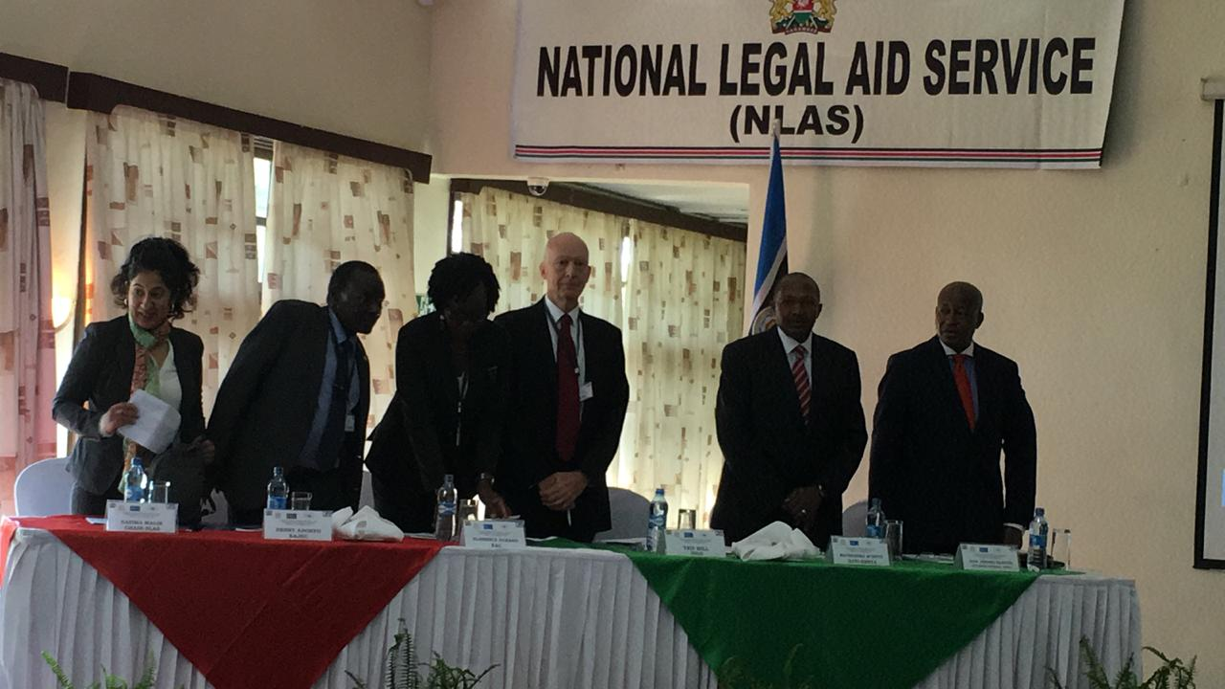

The opening session comprised a series of pace-setting speeches and presentations from high-level delegates in the governance, justice, law and order sector (GJLOS). On her own behalf and on behalf of all legal aid providers in Kenya, Ms. Nazima Malik, the Chairperson of the National Legal Aid Service (NLAS),Kenya, expressed deep appreciation to the organizers of the first EAC conference on legal aid and hoped that the conference would set the pace for further advances. She found the conference theme founded on the need for state-funded legal aid programs for marginalized and the indigent in the region to be a timely initiative to promote and improve access to justice for all.

Hon. Justice Kathurima M’Inoti, Judge of the Court of Appeal and current Director of the Judiciary Training Institute, Kenya (JTI), expressed his appreciation for the wealth of experience assembled at the conference, and underscored the importance of legal aid in facilitating the enhancement of equal access to justice and the rule of law. This, he emphasized, is a basic human right enshrined in international conventions and national constitutions world over, not least in Constitution of Kenya, 2010. Accordingly, it is a fundamental obligation and responsibility of every State to establish and facilitate the provision of legal aid to all citizens in need of such services.

Ms. Florence Ochago, Principal Legal Officer, East African Community Secretariat (EAC) expressed the EAC’s pride in contributing to a network with the avowed intent of improving access to justice through legal aid among citizens of East Africa. She lauded the existing synergies between the formal and alternative justice systems, and between state and non-state sponsored legal aid schemes, demonstrated by the continuing cross-referrals. According to her, the platform for cooperation already exists, and all it needs is support and consolidation for sustainability. She decried the present situation where most legal aid schemes depend entirely on support by development partners. Such schemes collapse as soon as donor-funding comes to an end. To ensure systematization, continuity and institutionalization backed by law, there is need for state-funded legal aid at both national and regional levels. She promised the EAC’s support for the regional legal aid initiatives as an important component of regional integration.

Mr. Ted Hill, Senior Legal Advisor-Program Development, (IDLO)expressed pleasure in attending the conference, whose concern for improved access to justice through legal aid was both timely and indispensable, being integral to rule of law and human dignity. He felt that that is a shared responsibility of both state and non-state agencies for the benefit of society at large, and especially its more vulnerable segments, such as thepoor and marginalized groups and communities, PWDs, PLWAs, women and children, the youth, and the elderly. He noted that IDLO remains the only international inter-governmental organization founded to help states entrench and develop the rule of law through institution-building, peace building and recovery from conflict.

The final Opening Remarks were delivered by Peter Adoyo, EAJEC, on behalf of Justice Stella Arach of the Supreme Court, Republic of Uganda and Chairperson of the East African Judicial Education Committee (EAJEC).In his remarks, Peter Adoyo conveyed the apologies of Justice Arach who, due to an urgent constitutional referral matter in Uganda, was unable to attend. Thanking IDLO, JTI and the EAC Secretariat for hosting the conference, he looked forward to receiving the first-fruits of the conference deliberations from the combined conference and EAJEC meeting. He decried the fact that, at present, his country Uganda doesn’t have a proper legal aid system, and its Justice Centres, which is but a rudimentary legal aid scheme, hasn’t worked quite well. He hoped to receive from the deliberations practical recommendations on how they could make the legal aid structure in Uganda more effective and coherent. He strongly felt that provision of legal aid is an inescapable state duty, and that it must be available for all legal matters, both criminal and civil, without discrimination because not everybody can afford the high cost of legal counsel. He looked forward to reviewing expert recommendations and take home lessons to help improve access to justice across the region.

5.1.2 Key Note Address
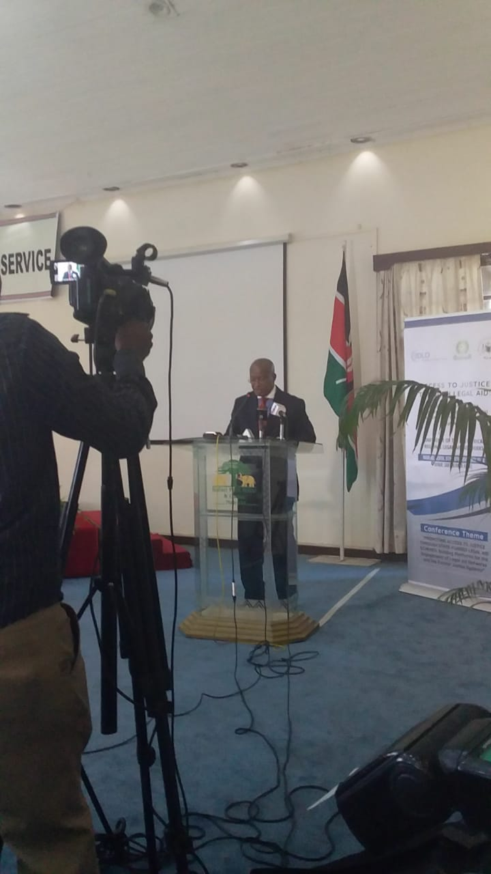

In his keynote address, Hon. Justice Paul Kihara Kariuki, the Attorney-General of the Republic of Kenya, extended a warm welcome to all participants and guests to the inaugural East African regional legal aid networks conference, whose importance in helping expand and enhance access to justice could not be overemphasized. He lauded their recognition of the role of the formal and informal justice systems, and the pursuit of justice for all. As a former long-serving trial judge and immediate former President of the Court of Appeal, he related a moving firsthand experience of the tribulations of accused persons and litigants who could not access legal representation and dire need for legal aid the

He stated that the focus in 18th and 19 centuries was on improving legal aid for the poor, hence the now over-used slogan of the ‘right to have one’s day in court’. Legal aid currently goes beyond the lawyer-client relationship and affordability of legal services to encompass advocacy for the indigent, legal information and advice to the vulnerable, community outreach and self-representation and ADR mechanisms. It evokes issues that go beyond fairness to include social order and stability. He further stated that access to justice directly impacts on peace and security, and on all facets of national development.

In his address, the Hon. Justice Kariuki identified various gaps in the attempt to guarantee access to justice through legal aid in East Africa. These include the mode of cooperation between legal aid providers, coordination and oversight of legal aid schemes, standardization, quality assurance, and funding. Whereas a measure of progress has been made in some respects, he underscored the importance of enhancing the scope of legal aid delivery, and the effectiveness of legal aid schemes. He called on the delegates to consider, among other issues, the geographical outreach, inclusiveness and sustainability.

Hon. Justice Kariuki called for the enhanced role of institutions of higher learning and legal training service providers in advancing legal aid and justice in conformity with international best practices, including extant UN guidelines on the provision of legal aid service by university law schools legal aid clinics, the provision of services and incentives to motivate students to participate in community-based legal aid clinics as part of their learning experience. By doing so, their heightened social responsibility to give back to society would become hard-wired into their DNA by the time they graduate, making it easier for them to continue the practice for life. He looked forward to engaging with the practical recommendations of the conference, which he believed will be useful in helping guide the harmonization of regional legal aid frameworks across the EAC.

5.2

Overview of the Program

The lead consultant, Dr.K. I. Laibuta briefly took participants through the conference theme, the conceptual framework, and the four-day programme. He drew the participants’ attention to the key agenda of the conference, including the need to, among other things, (a) explore effective and sustainable means of enhancing access to justice through legal aid; (b) interrogate the existing legal aid frameworks to make them more coordinated and effective; and (c) explore the possibility of deeper and more structured engagement among the institutions represented by the cross-section of delegates to the conference. Dr. Laibuta underscored the idea of legal aid as a State obligation, being alive as well to the challenges and impediments in discharging that mandate. He decried the present state where legal aid services (if available) are clustered almost exclusively around the urban and peri-urban areas. Hence the urgent need to expand the geographical reach of such services. In view of the fact that lawyers do not ordinarily establish their practice in poorer neighborhoods or remote and far-flung locations, the glaring gap in legal aid service delivery and access to justice can only be bridged by appropriate inclusion of paralegal services common in legal aid schemes.

In his remarks, Dr. Laibuta encouraged the delegates to, among other things –
(a) learn from one another lessons on the practical interface between the rule of law, judicial training, and community justice systems, and the manner in which they contribute to the realization of the right of access to justice;
(b) freely share experiences and take lessons and best practices from other legal aid schemes across the region;
(c) interrogate the existing legal aid models, institutional and regulatory frameworks, with a view of adopting models suited to the respective jurisdictions;
(d) make recommendations on the challenges, gaps, and capacity needs that need to be addressed;
(e) identify the appropriate model of state-funded legal aid schemes;
(f) discuss and recommend mechanisms for monitoring successes;
(g) consider and, if possible, adopt meaningful and practical networking models and collaborative mechanisms for legal aid providers for enhanced capacity for legal aid delivery by all; and
(h) consider and make recommendations on current funding gaps and the best funding models for sustainability.

After the opening remarks and keynote address, the conference proceedings were conducted in two breakout sessions to facilitate focused discussions on pertinent issues. The two groups focused on two main thematic areas. The first group, comprised of state and non-state agencies involved in legal aid service delivery, addressed issues relating to Legal Aid Networks, regional opportunities and challenges. The second group – the East African Judicial Education Committee (EAJEC) – retreated to discuss the intricacies of access to justice, and the role of judiciary training institutions in the promotion of access to justice through legal aid. Below is a summary of the deliberations of the regional Legal Aid Network and the respective experiences of Member States.

6. Emerging Themes and Issues

6.1 Introduction
The first day of the conference was divided into three substantive sessions during which the delegates shared experiences and lessons learnt by legal aid service providers within the 5 countries of the EAC, namely Burundi, Kenya, Rwanda, South Sudan, Tanzania, and Uganda. Other comparative experiences were drawn from Malawi, Somalia, South Africa, the USA and Zimbabwe. Additional comparative experiences from Vanuatu and the broader South Pacific region were shared to demonstrate the diversity of legal aid service delivery models across the world. Drawing from these experiences, the delegates proposed the adoption by Member States of mechanisms to promote policy dialogue on, among other issues–
(a) the establishment of suitable legislative, regulatory and institutional reforms to facilitate the administration of effective legal aid delivery schemes;
(b) the establishment of sustainable state-funded legal aid services; and
(c) strategies for ensuring effective and quality legal aid delivery by both state and non-state agencies.

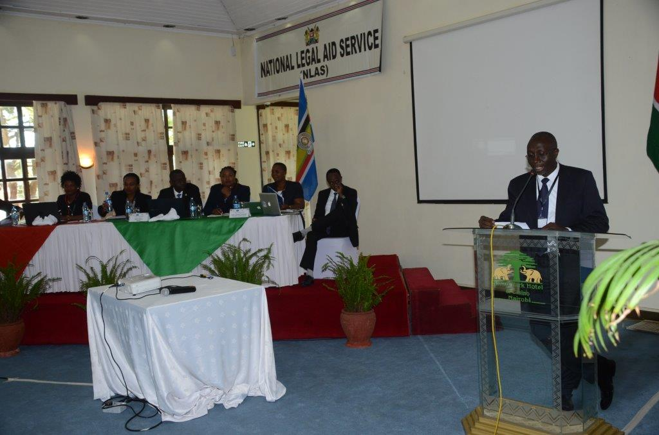
Experience sharing session by various Countries moderated by Eric Mukoya-ED-Legal Resources Foundation (LRF)

6.2 Experience Sharing By Legal Aid Organizations: Lessons Learnt, Challenges and Good Practices from the East African Region

List of Panelists
Name | Designation | Country
Lambert Nsabimana | Burundi Bar Association | Burundi
Christella-Kankindi | Legal Aid Burundi | Burundi
Miriam Wangari | Executive Director, FIDA-Kenya | Kenya
Caroline Amondi | National Legal Aid Service | Kenya
Andrews Kananga | Legal Aid Foundation | Rwanda
Sylvia Namubiru | Executive Director, Legal Aid Service Providers Network | Uganda
Felistas Joseph Mushi | Assistant Director, Ministry of Legal Affairs | Tanzania
Mohamed Abdillahi | Attorney General’s Office | Somalia
Moderator
Eric Mukoya | Legal Resources Foundation | Kenya

6.2.1 Burundi
The first panelist, Ms. Christella Kankindi, underscored the fact that equal access to justice is a fundamental feature of the rule of law. She drew the delegates’ attention to the International Covenant on Civil and Political Rights, the African Charter on Human and Peoples Rights and article 14 of the Constitution of Burundi all which recognize the right of an accused person to a fair trial, which is more often than not dependent on legal representation. Likewise, the Criminal Procedure Code and the law governing the prevention of Gender-Based Violence make legal assistance mandatory for certain categories of people, including -children in conflict with the law, PWDs, persons charged with an offence attracting a custodial sentence of more than 20 years, and victims of gender-based violence. At the policy level, Burundi’s National Legal Aid Strategy made provision for budgetary allocation to support legal assistance during the 2015-2016 financial year. By 2018, 5,100 beneficiaries, including 2,747 women and 408 victims of gender-based violence received legal assistance at the state expense.

In addition to the foregoing, the Government of Burundi has established the Judicial Assistance Committee, which receives and processes applications for legal aid. The Committee identifies and assigns legal counsel to legal aid beneficiaries, receives and responds to all cases involving legal aid in the country, and is in charge of the translation of the core national legal texts into Kirundi, the local vernacular. Owing to the government’s public awareness and outreach efforts, every year at least 60,000 people are informed of legal aid provisions and opportunities.

Despite these achievements, Burundi faces various challenges in legal aid service delivery, which include (a) ignorance of the law by large segments of the population; (b) violation of the law by unscrupulous individuals; (c) lack of geographical reach by the public legal aid programmes; (d) lack of seamless coordination among players in legal aid; and (e) the instability of civil society organizations, which play an important part in the national legal aid service delivery. Other challenges include the need for capacity building of lawyers to better provide legal aid, which is presently provided by young and relatively inexperienced lawyers.

In response, the Government of Burundi has taken a raft of measures to address these challenges. These include, (a) the development and operationalisation of a framework for legal aid service delivery;(b) undertaking stakeholder mapping in legal aid; (c) the establishment of a consultation framework among legal aid players; and (d) the establishment of a public legal aid fund.

Mr. Lambert Nsabimana added that legal aid programmes in Burundi were first initiated by the UN in the 1990s. The Ministry of Justice has formally taken over the operations and administration of the programme. The Ministry has embarked on streamlining operations and removing unnecessary impediments on the scheme, such as where judges and magistrates declined to adjourn cases to allow accused persons to seek legal representation. In addition, the law in Burundi provides that victims of human rights violations are entitled to legal aid.

At the apex, the legal aid scheme in Burundi is comprised of the Ministry of Justice and its legal aid programme, through which legal advice is accessible to eligible applicants before going to court. The programme supports self-representation, legal advice and representation, and ADR options. The Burundi Bar Association has been a steadfast partner and supports the state-sponsored programme through its pro bono lawyers’ Association. The Association ensures that there is at least an advocate or two on duty to provide legal aid to designated persons. Next on the hierarchy are the Judicial Assistance Committees, which are court-level committees that sit once or twice a week to consider eligible cases. Cases eligible for legal aid are forwarded to the Bar Association according to need. This has ensured effective intervention and coordination among non-state agencies, including those that provide financial and technical support. In its National Legal Aid Strategy, the Ministry of Justice in Burundi has defined government priorities, which include access to justice through legal aid. The Ministry has prepared a Bill, which is awaiting tabling in Parliament for enactment to entrench legal aid in legislation.

6.3 Kenya
Caroline Amondi informed the delegates that historically, legal aid in Kenya was provided by civil society organisations. Legal aid programmes in Kenya began with the University of Nairobi’s Faculty of Law legal aid clinic, whose objective was to provide legal advice and other legal aid services to disadvantaged and vulnerable groups in distress. This led to the creation of Kituo cha Sheria forty-five years ago, which makes Kituo Cha Sheria the oldest legal aid provider in Kenya. In addition to Kituo Cha Sheria’s initiative, the Judiciary also had an administrative agreement under the Pauper Brief scheme which continues to date, where judges requested advocates in court to give legal assistance to accused persons in complex cases. Over the years, other civil society and public benefit organizations, such as FIDA Kenya, the Legal Resources Foundation, CRADLE, only to name a few, have joined Kituo Cha Sheria in providing legal aid services in programme-specific areas of their interest. In 2007 then Ministry of Justice and Constitutional Affairs established a National Steering Committee for the National Legal Aid and Awareness Programme aimed at formulating a policy framework for a national legal aid scheme in Kenya. The pilots of the programme which were run jointly with various state and non-state agencies were launched in 2009 to pilot on six thematic areas namely; Capital offences, Robbery with Violence, Alternative Dispute Resolution-Mediation, Family Law, Paralegalism, Children in conflict with the Law and Children in need of care and protection. . The lessons drawn from the pilots informed the development of the National Legal Aid and Awareness Policy, 2015 and the Legal Aid Act, 2016

The Constitution of Kenya, 2010 obligates the State to guarantee the right of access to justice for all and where fees is required it should not be an impediment. Recently there have been judicial pronouncements regarding, the right to legal aid in criminal cases with the emphasis on granting legal aid as a matter of right in cases where the accused stands to suffer substantial injustice. . In addition, the right of access to justice through legal aid has been the focus of programme-specific initiatives of a diverse range of civil society organizations. Presently, Kenya enjoys a sound legal framework for legal aid service delivery with the Legal Aid Act, 2016 coming into force on 10th May 2016. Section 2 of the Act gives a broad and inclusive definition of legal aid. The Act, which is backed by the recently-formulated Regulations that are in the process of publication, sets out the eligibility criteria for legal aid, prescribes the means test and the procedure for accreditation of legal aid providers. In addition to the Regulations, the National Legal Aid Service has put in place a Code of Conduct for Legal Aid Providers. The establishment of the National Legal Aid Service, the Legal Aid Fund, the anticipated publication of the Regulations and Code of Conduct, reinforces the existing legislative and regulatory framework for the administration of legal aid service delivery in Kenya.

The eligibility criteria for grant of legal aid under the scheme in Kenya is suitably designed to ensure that no person deserving of legal aid is unfairly excluded from the scheme. Among the persons eligible for legal aid are victims of human trafficking, children, refugees, and the indigent – those who have a net monthly income of less than thirty thousand shillings. The other factors for consideration in determining eligibility include the merits of the case, proportionality, and likelihood of substantial injustice, the impact, and bearing on public interest.

The National Legal Aid Service works closely with the Judiciary, the Police, the Department of Correctional Services, the Department of Children Services and other justice sector institutions who may cases for consideration for grant of legal aid. The Regulations require judicial officers, officers in charge of police stations and prisons to inform victims of offences and accused persons of the availability of legal aid.

NLAS administers the legal aid fund, which is financed by budgetary allocations from the Consolidated Fund as well as by gifts and donations from citizens and Development Partners. The Service coordinates legal aid service delivery throughout the country. The governance Board of the Service is composed of representatives of CSOs, the Treasury, the Judiciary and other state and non-state agencies in the justice sector.

The key achievements of NLAS include (a) the adoption of ADR mechanisms in conflict management and dispute resolution; (b) streamlining interagency referrals and coordination of training of legal aid service providers and c) development of policy documents to guide implementation of the Legal Aid Act, 2016. The Kenyan model comprises a mixed delivery approach that involves state and non-state agencies.

Inadequate funding remains top on the list of challenges to effective legal aid service delivery in Kenya. Legal aid remains the lowest funded programme within the GJLOS sector. Other challenges include the resistance by the legal fraternity to recognise the critical role of paralegals play in the provision of legal aid services. However, this challenge has somehow been addressed by the statutory recognition of paralegals as key players in the national legal aid scheme. The Act recognizes paralegals and provides for their accreditation through accredited legal aid providers, or as employees of the NLAS, who can offer legal aid services. Finally, the initial mapping of legal aid providers in Kenya to aid in the implementation was not very successful as very few responded and were mainly from Nairobi.

Miriam Wachira-FIDA-K: One of the premier legal aid service providers that deserves special mention is FIDA-Kenya, which provides legal advice to between 40 and 50 women daily. The women, who are mainly involved in marital and succession disputes, are trained in self-representation in court, civil procedure, and drafting their own pleadings. In addition, FIDA provides legal representation in cases where their clients are incapable of representing themselves. In such cases, FIDA enjoys the support of pro bono lawyers

In addition to legal advice and representation, FIDA has adopted mediation as a means of resolution in family matters, in which they have registered a 70% success rate. The mediation service has gathered pace with 60 or so mediations conducted every week. The demand for this ADR service keeps rising.

FIDA-Kenya has also embarked on the training of paralegals and traditional justice actors on legal aid. As experience has shown, paralegals are best placed to offer help at the community level at which FIDA-Kenya plays an advisory role. This programme has facilitated the resolution of land and matrimonial disputes in collaboration with indigenous Councils of Elders. The process has proved to be expeditious, accessible and affordable. The approach is restorative and guarantees consumer satisfaction in contrast with court litigation, which ultimately destroys family relationships.

The challenges faced by FIDA-Kenya and other legal aid providers include (a) inadequate funding in the face of high and increasing demand for legal aid services;(b) high demand for legal representation;(c) low uptake of pro bono services among lawyers;(d) inadequate human capacity;(e) high operational expenses;(f) low uptake of mediation as a cost-effective means of dispute resolution;(g) long court processes; and (h) power imbalance in community justice systems administered by Councils of Elders (which are dominated by men),which make women uncomfortable before them.

6.4 Rwanda
Andrews Kananga: Though a relatively late entrant into the legal aid service arena, Rwanda is first catching up. The country is in the process of establishing a comprehensive legal aid framework with the National Legal Aid Policy and a draft Bill pending before Parliament. Rwanda has adopted a broad definition of legal aid in its National Policy providing legal aid in both criminal and civil matters. The scheme incorporates informal justice systems, which drew international attention during the trial of genocide suspects from the International Criminal Tribunal for Rwanda. The trials, which were inexpensive and expeditious, were conducted by lay people in the Gacaca courts, which were comprised of local elders and other respected persons nominated by their respective communities. Likewise, the Abunzi community justice system – a community mediation system –renders mediation services at no cost to the community.

The Rwanda National Legal Aid Policy obligates the Government to provide legal aid services through a state or non-state agency mandated to oversee legal aid service delivery in the country. The Constitution and the Law governing the exercise of the judicial authority of the Supreme Court and other judicial institutions provide the legal framework for the provision of legal aid in Rwanda. In addition, the Law under which the Rwanda Bar Association is established imposes an obligation on lawyers to provide pro bono services. In this regard, the Ministry of Justice is obligated to make budgetary allocations to support this programme.

The Legal Aid Forum is one of the most innovative programmes in Rwanda. Since2009, the government has utilized ICT innovations to disseminate information and create legal awareness among the people. Rwanda observes the legal aid week every year organized by the Ministry of Justice in collaboration with the Rwanda bar Association. Thousands of people have benefited from this programme. In September 2018, Rwanda launched the ICT platform to expand legal aid service delivery. The platform – code 845 – is designed to share important messages relating to legal aid through Short Message Service (SMS) and Interactive Voice Recording (IVR). The legal aid programme in Rwanda recognises ADR as a vital component of dispute resolution.

Financial constraints present the greatest challenges to Rwanda’s legal aid programmes. The Government is only able to finance retention of officers in national legal aid bureaus across the country, leaving out many non-state agencies that play a critical role in the promotion of access to justice through legal aid. In addition, the legal aid guidelines have only recently been approved and devolved. The rising demand for legal aid services in Rwanda is far from being met.

6.5 Tanzania
Christina Kamili: Legal aid in Tanzania is governed by the Legal Aid Act, 2017, which came into operation in July 2018. The enactment of this statute was informed by benchmarking studies conducted in Uganda and Malawi in 2013. The Act created the Office of Registrar of Legal Aid Providers to coordinate legal aid service delivery, as well as a multi-stakeholder National Legal Aid Advisory body.

Prior to the enactment of the 2017 Act, legal aid in Tanzania was based on the Criminal Proceedings Act of 1969, which restricted legal aid to murder cases. Under the 2017 Act, the Judiciary has power to order provision of legal aid at the state expense in both civil and criminal cases. The legal framework has not only expanded the scope for legal aid, but has gone a long way in recognising the critical role played by paralegals and prescribing qualifications for inclusion in the scheme.

The 2017 Act clearly defines the institutional framework for legal aid service delivery in Tanzania. The Act establishes administrative structures at the national, regional and district levels. At the national level sits the Ministry of Constitutional and Legal Affairs, with sub-structures at the regional and district levels. These are headed by community development officers officially designated as Assistant Registrars who coordinate legal aid delivery at the regional and district levels.

In places of detention, the Act requires police officers and prison warders to facilitate access to legal aid by remandees and detainees. To this end, police and prison officers are trained to provide basic legal advice on matters relating to legal aid. Presently, more than 100 officers have been trained to provide legal advice in prison and police stations.

The legal aid scheme in Tanzania has its fair share of challenges. Lack of adequate funding remains the main impediment. In addition, the Legal Aid Advisory Board is yet to be established. The scheme mainly depends on government allocation supplemented by funding from Development Partners. Other challenges include (a) limited human resource capacity; (b) lack of financial resources to train and build the capacity of paralegals; and (c) lack of acceptance and appreciation by the legal fraternity of the vital role played by paralegals in legal aid service delivery. Paralegals are often referred to as “bush lawyers”. Despite the sound legal framework for the administration of legal aid, Tanzania is yet to take regulatory measures to ensure quality service delivery, including a structured process for accreditation of legal aid service providers. The need to establish an effective monitoring and evaluation system was underscored. Such a system would help legal aid service providers to ascertain what was working and what required improvement.

Notably, the Ministry of Constitutional and Legal Affairs is in the process of establishing an online system for registration of legal aid providers. The system will also be used to generate statistical data to inform future programmes, plans and actions toward an effective legal aid service delivery model. To this end, civil society organisations have taken steps to establish an online network of Legal Aid Providers, which is accessible in all parts and regions of the country.

Tanzania’s enactment of the Legal Aid Act ahead of Uganda and Rwanda, who had a head start and with whom Tanzania benchmarked, demonstrates political will on her part. The country recognizes legal aid as a key pillar of the rule of law and fair trial, which in turn depends on wide ranging partnerships, collaboration and synergies. In cognizance of that fact, the Government consulted widely with MPs, public officers, and other non-state agencies before coming up with the statute law.

6.6 Uganda
Sylvia Namubiri: Despite its unique challenges, Uganda has in place a legal aid system. Presently, the scheme covers legal advisory and representation, and engages paralegals in its pool of legal aid service providers. The paralegals are specially trained to raise legal awareness and empower local communities to assert their right of access to justice. Uganda’s national legal aid framework is anchored on international and regional standards, and on Articles 8 and 20 of the Uganda Constitution, which guarantees the right to legal representation for people charged with capital offenses. The Poor Persons Defense Act applies to civil cases where an applicant is declared a pauper. The national policy on legal aid makes provision for pro bono services to the indigent, as well as an obligation for law students to provide legal aid services.

The Uganda Law Council Regulations for Legal Aid are currently under development. Presently, Uganda has no statutory framework to regulate legal aid service delivery. However, Uganda’s legal aid policy is awaiting Cabinet approval to set the pace for a legislative framework. The delay has prompted civil society organizations in the justice sector to sponsor private-member motions to compel the Attorney-General to initiate the legislative process toward enactment of statute law on legal aid.

One of the initiatives launched by civil society in Uganda is the Justice Centres Uganda, which is a public legal aid model funded by development partners. This model engages paralegals. The Uganda Law Society has not been left behind. Under its pro bono programme initiated by the Uganda Law Council and implemented by the Uganda Law Society, every advocate is obligated to provide at least 40 hours of pro bono service every year as a condition for renewal of their practicing license. Over 54 civil society organizations have provided legal aid services in one form or the other during the last 40 years.

Uganda’s legal aid programmes are guided by a defined eligibility criteria based on the “Means and merits test” to determine who qualifies for legal aid. Other criteria include vulnerability and poverty. The system heavily relies on advocates employed by the organizations, community and professional paralegals, and pro-bono advocates.

The main challenges facing effective legal aid delivery in Uganda include (a) high demand for legal aid – 80% of Ugandans cannot afford legal services; (b) insufficient and uncoordinated legal framework, with no proper state-funded scheme in place; (c) ethical issues and concerns among legal aid providers; (d) the donor-driven nature of most public aid schemes, raising issues of sustainability in the face of donor fatigue and shifting priorities in international development programmes. Finally, the legal and regulatory framework requires comprehensive reforms to address issues of human resource capacity, geographical outreach, and the quality of service delivery.

6.8 Plenary Session
In the ensuing plenary session, the delegates shared additional country experiences. Uganda has 10 legal aid organizations that work nationally out of the accredited 72, each of which has paralegals among their personnel. The country has streamlined ADR practice, particularly mediation, even though mediation has not been embraced by lawyers, perhaps out of fear of competition and loss of business. To address this misconception, the country has introduced a course on legal aid in law school curricula to increase awareness on legal aid among the legal fraternity. In addition, law schools have also introduced legal aid clinics to induct the students into the scheme. Uganda is also pursuing Public-Private Partnerships (PPPs) with local governments and other non-state agencies with the aim of attaining an effective legal aid service delivery model to meet the increasing need for equal access to justice. All these initiatives are geared towards establishing a robust state-funded legal aid scheme.

Burundi, with 17 provinces, has taken steps to expand the geographical reach of their legal aid service delivery by covering at least 10 provinces, concentrating on highly technical cases only. However, sustainability still remains a challenge, since funding is still primarily from technical and financial partners. The Ministry of Justice has tried to equalize funding across the provinces based on priorities as set out by the National Legal Aid Strategy. According to the strategy, paralegals are recognized up to the lowest community level. Political leaders have been sensitised to support the setting up of the National Legal Aid Fund.

Rwanda reported that the country has 15 institutions in the GJLOS sector, and is presently in the process of consolidating their funding into one national fund.

It also became clear that the national legal aid schemes need to engage more constructively with their respective budgetary processes so as to ensure that the annual budgets are more responsive to programmes relating to access to justice. Concern was raised by delegates about the level of tolerance for certain minorities and marginalized groups who have suffered persecution in some countries in the region. The delegates underscored the need to expand the geographical outreach of present legal aid schemes so as to guarantee equality of opportunity to access justice.

The delegates raised issues concerning the recognition and accreditation of paralegals and noted Kenya’s shining example in this regard. Delegates were informed that in Kenya, according to the Legal Aid Regulations validated in October 2018, paralegals are engaged in the national legal aid scheme in two ways – directly by the NLAS and through accredited legal aid providers. Other non-state agencies and accredited legal aid service providers, such as African Prison Projects, LRF, and Kituo cha Sheria, have taken the initiative to train paralegals. Delegates also discussed concerns regarding the independence of fully state-funded legal aid schemes and recommended that such schemes be autonomous to avoid state interference.

Concern was also raised regarding the sustainability of the present legal aid models across the region. It was noted that almost all schemes depend on donor funding, which is by no means sustainable.

In conclusion, it was recommended that mechanisms be established to encourage innovation and the use of technology in legal aid service delivery. Law schools, universities, judicial training institutes and all players were encouraged to identify, document and share lessons from home-grown innovations which may offer the best fit for legal aid in the EAC context.

7. Experience Sharing by Legal Aid Organizations: Lessons Learnt

7.1 Challenges and Good Practices from other Regions

List of Panelists
Name | Designation | Country
Dr. Jerry Makokoane | Chief Operations Officer, Legal Aid South Africa | South Africa
Clifford Msiska | Paralegal Advisory Services Institute | Malawi
Eric Mukoya | Legal Resources Foundation | Kenya
Ted Hill | International Development Law Organisation | Hague
 | Moderator
Vincent Mutai | Lecturer, Faculty of Law, Moi University and NLAS Board member | Kenya
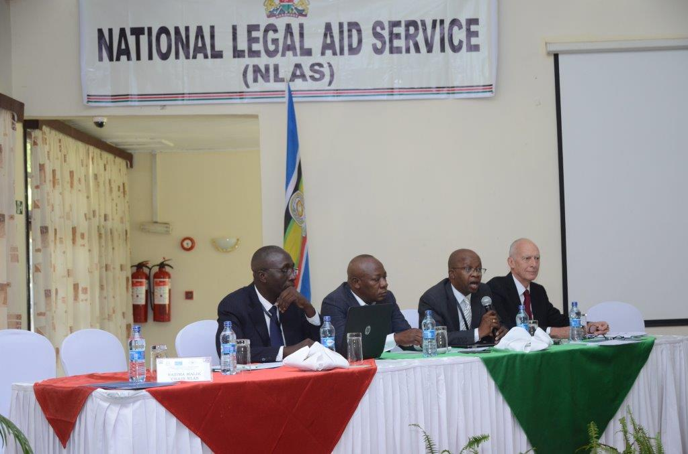

7.1.1 South Africa
Dr. Jerry Makokoane: Legal Aid South Africa was established as an independent public and fully state- funded body to take charge of all public legal aid programmes in the country. The body has since documented processes and systems, which has been a long journey and a learning process, considering that South Africa had no home-grown or global best practice guidelines to take lessons from. Judicare services, cooperatives and agencies constitute the main agencies in legal aid. However, South Africa faces the perennial challenge of getting experienced lawyers to work in legal aid institutions, as Judicare model is largely viewed as unsustainable.

To address these challenges Legal Aid South Africa formulated creative local models of legal aid delivery. It has established an accreditation system that takes care of experiences of the lawyers as well as victims/clients, their legal interest and specialties, which it uses to match cases for assignment to lawyers. Legal Aid South Africa presently has more than 128 Local Offices countrywide, and it actively leverages on IT services for outreach. Every Local Office is headed and managed by a qualified senior lawyer. It has developed leadership programs for all local office managers to infuse management and leadership thinking. Consequently, it has emerged as one of the most reputable and high-performance institutions in the country, and has been voted the top employer in the South African public sector for 10 years successively. It offers advocates competitive salaries that are fairly comparable with the private sector . Accordingly, the body is able to attract highly experienced legal practitioners for guaranteed quality legal aid services. To safeguard quality service delivery, Legal Aid South Africa has instituted a robust quality assurance system that comprises evaluation by self, peers and outside practitioners.

7.1.2 Malawi
Clifford Msiska:The Malawian experience confirms that access to justice requires a combination of legal advice, legal assistance, empowerment, legal representation and ADR services. Based on its home-grown approach, Malawi has benefited from several enviable achievements. These include the use of paralegals in police stations, courts and in prisons, a support system that has greatly improved access to justice by remandees and persons held in detention. The paralegals work on a full-time basis, especially on matters involving children. As a result, Malawi recorded reduced remand prisoner numbers from 60% to 20%. There are also other paralegals that offer mediation services at the village level and are referred to as Village mediators. They are the only ones who are suitably placed to assist the poor and marginalized members of the community by reason of the fact that they live among them, understand their cultures and customs, and do not mind working and living in poor neighbourhoods. They are of great help in promoting preventive justice, considering that unresolved disputes pose the risk of serious crimes.

The Legal Aid Bureau, a quasi-government institution, acts as the national legal aid coordination committee for all legal aid providers in Malawi. The bureau has signed cooperation agreements with other service providers. One of the main challenges has been the reluctance to recognize paralegals, despite their well-documented role in providing legal aid in the country, with the result that their services are not legitimized or recognized in law. What clearly emerges is that paralegals play a critical role in providing the kind of low level legal aid that most rural populations require. Their services are accessible and cost-effective.

7.1.3 Kenya
Eric Mukoya: Legal aid is requisite to the realization of the right of access to justice as guaranteed under Articles 25, 28, 48and 50 of the Constitution. Legal advice, assistance and representation are vital to the realization of this right. Yet out of the 16,000 qualified lawyers, an estimated 14,000 of them are found in cities and urban areas, leaving only a handful of them in rural areas. This puts legal services out of reach for the majority of Kenyans.

These statistics show that the journey in the establishment of an effective legal aid service scheme has a long way to go. This is more so when emphasis continues to be laid on judicial proceedings. Notwithstanding this unfavorable situation, Kenya has employed various innovations to address the yawning gaps in geographical outreach of legal aid service delivery countrywide. In addition to the formal judicial system, community justice systems have played a complimentary role in dispute resolution in rural communities.

Among the innovations reported from Kenya is the re-packaging of legal aid as complementary and not in competition with legal services rendered by advocates. This has helped break the resistance among lawyers and the state, which are wary of the competitive model of legal aid. In addition, Kenya has a pro bono lawyer scheme in aid of, among others, children, women, and victims of Sexual and Gender-Based Violence (SGBV).The poor distribution of judicial institutions and officers in rural communities also stands in the way of access to justice. In Turkana County, for instance, there is only 1 prosecutor who serves 4 courts, 3 magistrates and one presiding judge despite the escalating conflicts. Kenya has also adopted a victim-offender mediation approach, which has made mediation an effective means of access to justice.

The country has also introduced paralegal services in the community, police, prisons and the courts. In addition, Kenya has deployed the Court Counsel Concept, whereby a desk is provided at the court, which acts as a one-stop shop for some legal advice on what to do or expect in court. Regarding giving incentives to lawyers to provide pro bono legal aid services, the country continues to try out various initiatives, including legal aid clinics ran by university law faculties and the annual legal aid week by the Law Society of Kenya where participating advocates are awarded Continuing Professional Development credits. Apart from the perennial challenge of funding constraints, the country has made attempts to establish and enforce standards and benchmarks for legal aid.

7.1.4 Vanuatu– Lessons from the South Pacific
Mr. Ted Hill (Senior Legal Advisor-Program Development, (IDLO)shared experiences from the South Pacific Ocean island nation of Vanuatu, one of the poorest and least developed countries in South Pacific .Its experiences could be applicable to much of the Global South, where the EAC countries fall.

Experiences from Vanuatu show that, as opposed to a centralized national approach to legal aid, the island nation has deployed a creative, grassroots oriented, bottoms-up approach. By doing so, the country has struck a balance between the quality and geographical outreach in legal aid service delivery. This model was developed at the University of South Pacific. This approach was supplemented by lessons ran by the University legal aid clinic, which was part of a fourth-year credit course. It emphasized skills over theory, putting ahead real life skills in negotiation, interviewing, drafting, research and legal advice, but without court representation. The programme accommodated up to 6 students per day, 5 days a week. In actual practice, the initiative interfaced with the Public Solicitor Act as the framework for legal aid, worked with the Vanuatu Public Solicitor to develop civil and family law practice. Cases were only accepted on referral from the Public Solicitor, which eliminated the need for screening.

Since the course focused on legal literacy and empowerment, the participating students were required to develop brochures on various aspects of the law to raise legal awareness among the general population. The brochures were printed and distributed in the local communities. The course immersed all law students into legal aid as a matter of necessity. These academic requirements grounded them in law practice even before graduating from law school.

This program was later faced with logistical challenges arising from the global shift to online learning whereby students were not required to attend university for face-to-face instruction. In addition, the legal education programme was expanded to include actual court representation, which greatly expanded the scope and number of cases dealt with. This soon made it unmanageable and impacted negatively on the quality of its delivery. Consequently, the programme was abandoned.

The delegates drew valuable lessons from the experience in Vanuatu. Law students can play a crucial role in an inclusive legal aid scheme with proper instruction and supervision and creative use of university curricula. However, the availability of free legal services to only one party in the proceedings while the other is left unrepresented has the effect of creating imbalance in the judicial process. Other models that have been tried include the placement of students in law offices, from where they are expected to keep a diary of daily cases and practices. This prepares them for a future of service in similar programmes.

7.2 Strategies to Overcome Challenges in the Implementation of Legal Aid Service Delivery
(Moderator–Jedidah Waruhiu Commissioner , KNCHR and NLAS Board Member)

7.2.1 Legislative, Institutional and Administrative Frameworks
During this session, the delegates were divided into two thematic groups. Group 1addressed “Mechanisms to promote policy dialogue on the law, regulatory and institutional mechanisms, and funding for legal aid services” while Group 2 discussed “Ensuring Effective Legal aid delivery systems and quality of legal aid services”.

The two groups were asked to (a) analyze the existing models for overcoming challenges in legal aid service delivery; and (b) identify the most effective state-funded legal aid delivery models for possible adoption across the EAC. Each group addressed the key issues facing various legal aid frameworks in the region. They analyzed their defining features, such as (a) sustainability; (b) scope of legal aid and geographical outreach;(c) the quality and scope of service delivery;(d) financial models;(e) the administrative frameworks; and (f) the coordination mechanisms, and the underpinning legal frameworks.

From the group discussions, it emerged that the pressing need for legal aid services could not be overemphasized. Statistics showed that more than 100,000 people were held in remand or imprisoned every year in East and Southern Africa. This calls for the upscaling of legal aid service delivery to meet the pressing needs of those unable to afford legal representation. Accordingly, there is need to enhance the existing probono services in the region. The groups noted that the only pro bono models presently in existence were (a) the court-led pro bono service under the respective pauper brief systems;(b) the pro bono service schemes administered by respective bar associations;(c) the civil society legal aid delivery models; and (d) the various programmes in which paralegal are actively engaged in providing basic legal advice and assistance in local communities.

The delegates began by drawing lessons from Tanzania. The Tanzania Legal Aid Act No. 1 of 2017 recognises paralegals and provides for their registration and accreditation on payment of a registration fee. However, this presents a challenge since most paralegals are based in the rural areas and are unable to afford the registration fee. Financial support to paralegals to cover the mandatory registration fees is therefore necessary inoder to engage them. . In addition, funding remains the main challenge. Delegates were also told that the new rules ratified in 2015 now provide for the partial or complete waiver of court fees for indigent clients, but only on application and approval. While paralegals may represent parties in the Labour Court, they are required to file a notice of representation. Even though they have the right to charge fees for such representation, there is no schedule of the recommended fees chargeable, which creates uncertainty in remuneration.

In Kenya, the Legal Aid Act recognizes paralegals and provides for development of a training curriculum by the National Legal Aid Service in consultation with Council for Legal Education. Their formal recognition has given impetus for the use of paralegalism as a model of legal aid service delivery model as opposed to the informal community-based engagement outside the national scheme. The only challenge is the risk of exclusion of a large number of paralegals engaged in the community-based initiatives due to their inability to meet the basic qualifications for registration and accreditation. Concern was raised as to the risk of minimizing the engagement of paralegals under the scheme. However, the need to set standards to guarantee quality service delivery could not be overemphasized.

With regard to Malawi, delegates grappled with the issue as to whether it was time to allow paralegals to appear in court and provide legal representation in certain cases. It was noted that paralegals may represent their clients in bail application at police stations, but cannot appear and represent them in court. However, paralegals may provide legal representation in Small Claims Courts, as is the case in Tanzania, where law so allows. In Kenya, an intermediary is allowed to assist a litigant communicate with the court, which does not amount to representation.

Uganda has no regulatory mechanism for the training, regulation and accreditation of paralegals. It is likely that Uganda will adopt the Kenyan model of legal aid delivery, which engages accredited legal aid providers, who include paralegals, advocates, firms of advocates, civil society organisations, public benefit organisations, faith-based organisations, university law school legal aid clinics, and state agencies. If Uganda adopts the Kenyan model, the challenge will be how to determine the remuneration of paralegals.

The legal aid schemes in Kenya and Rwanda have benefited from the engagement of university faculties of law that operate legal aid clinics, as well as from individual advocates and law firms. The Rwanda Advocates Act requires practising lawyers to handle at least one pro bono case each year as a condition for renewal of their annual practice license. The group welcomed the idea of a statutory requirement for lawyers to provide some measure of pro bono services as a way of giving back to the society. They expressed the view that one case per year was too modest, and that increasing the number would boost the effectiveness of the legal aid scheme. -The participants were however concerned that this statutory requirement prescribes no standards for the type or quality of legal assistance/representation, posing the risk of lawyers rendering token pro bono service merely to “tick the box.”

The experience in Uganda shows that the country operates a state-sponsored pro bono brief scheme mainly in criminal cases. However, the scheme faces challenges in human resource capacity and scarcity of lawyers willing to take up such cases on voluntary basis. In addition, there is no clear mechanism for M&E for pro bono services, which have been left to junior lawyers struggling to make a living. This impacts negatively on the quality of legal aid services offered. The present legal framework does not provide for a structured legal aid scheme despite the steps taken over the last 10 or so years towards its creation. It is to be noted that it is mandatory for every advocate to provide forty (40) hours of pro bono legal services per year or pay a fee prescribed by the Ugandan Law Council in lieu of such services.

Unlike Rwanda and Uganda, there is no requirement for mandatory pro bono service in Kenya requiring advocates to provide legal aid as a condition for licence renewal. The pro bono service is purely voluntary and mainly undertaken during the annual legal aid week organised by the Law Society of Kenya where advocates earn continuing professional development points. During this week, advocates volunteer to provide legal advice at various legal aid camps set up in various court stations across the country. Notably, most of these camps are located in large urban centres where most advocates practice.

In addition to the services provided by legal counsel under the pro bono service scheme administered by the Law Society of Kenya, the delegates were appraised on the Judiciary’s critical role in the provision of legal aid through the pauper brief system. Under this system, the office of the Registrar High Court assigns volunteer advocates the task of representing accused persons charged with capital offenses. This scheme administered by the Judiciary has also not yielded much success even though it plays an important role in case-flow management.
In civil cases, indigent persons are entitled to apply for an order of the court to sue as paupers, i.e., without payment of the requisite court fees. Likewise, persons with disabilities are entitled to waiver of court fees in any case where they seek to enforce disability rights under the Persons with Disabilities Act, 2003.

In South Africa, pro bono legal aid service delivery by private law firms has not been successful. However, there are a number of laudable successes, such as the NGO, Probono.org, who came up with mechanism to recognize lawyers who provide pro bono legal services, a move that has enabled Legal Aid South Africa to ride on this system to recognize lawyers who do well in particular cases and assign them more briefs.

South Sudan, which has endured a long period of internal instability and civil strife, has no framework for legal aid. The Ministry of Justice recently finalized a strategic plan– the Legal Framework 2018-2028. The present system features a cooperation mechanism between the Ministry of Justice and the South Sudan Bar Association, which seconds lawyers to provide legal aid services while the Ministry settles court fees on account of eligible applicants. With regard to pro bono services, the South Sudan Bar Association operates a Free Consultation Bureau. Under the programme, 1 or more lawyers offer free consultation to individual applicants. The programme enjoys occasional donor support.

The session concluded with a discussion on Burundi. Burundi’s legal aid programmes have historically been dominated by non-state agencies. However, most of them have withdrawn legal aid services due to financial constraints. To address this gap, the Ministry of Justice is in the process of putting in place a Legal Aid Strategy.

7.2.2 Funding Arrangements
After comprehensive discussions on the legal and administrative frameworks, the delegates focused on funding for legal aid in the region.

In Kenya, the Government is obligated to fund legal aid as a vital component of the right of access to justice as guaranteed under Article 48 of the Constitution, and by a diverse range of regional and international human rights instruments that Kenya is party.

To this end, the Legal Aid Act, 2016 establishes the NLAS, a governance board, and a legal aid fund, through which the Government aims at ensuring equal access to justice through legal aid. The recently formulated Legal Aid Regulations sets out the criteria for eligibility and regulates the accreditation of legal aid providers. Even though the scheme is state-funded, the Service continues to face financial constraints. However, it is expected that the diverse range of non-state legal aid providers will join hands in engaging development partners to lend financial support in various programme-specific legal aid initiatives. Indeed, sustainability remains the main concern.

The South African delegates expressed concern over governments’ reluctance to underwrite state-funded legal aid due to financial constraints. In order to interest the state in funding legal aid schemes, they recommended that legal aid providers take a gradual and piece-meal approach, beginning with issues and projects that strike chords with the political leadership, which is usually quick to please the electorate by taking popular stands on topical issues of public interest. Legal Aid South Africa has adopted this approach by capturing all information and other published trends, which they use for lobbying and advocacy.

The Rwandan delegates recommended a home-grown legal aid delivery model. According to them, there cannot be a one-size-fit-all scheme. They cautioned against the inclination by Member States to adopt legal aid delivery models in developed jurisdictions, most of which have universal and sustainable legal aid insurance schemes. In contrast, the EAC and the, African region as a whole have limited resources. Moreover, legal aid is in itself a form of insurance and requires considerable financial outlay. Yet the option of business models– where legal services are paid for – present challenges in view of Africa’s widespread poverty. Whatever the case, Member States are duty-bound to discharge their constitutional and international obligations to guarantee and facilitate equal access to justice through state-funded legal aid schemes.

To ensure sustainability, LRF-Kenya recommended the adoption of legal aid schemes that capitalized on legal empowerment and self-representation in court proceedings. This requires legal awareness and training to empower the communities. According to them, paralegals play a critical role in raising legal awareness- at the community level, which reduces dependency on legal counsel.

FIDA-Kenya has adopted self-representation training model, including drafting pleadings, correspondence and formal notices for its clients. This approach lessens the burdens placed on legal aid providers, as minor issues are left to individual clients. Under this model, FIDA continues to play an advisory role as individual clients take charge of court proceedings. The sustainability of this model requires continuous training and capacity building of local communities. This model ensures maximum support by CSOs of the state-funded legal aid scheme. On the other hand, CSOs continue to administer specialized programs on legal aid.

The delegates observed that legal aid should not be restricted to legal representation. Rather, the scope of legal aid should be expanded to cover the provision of legal information, advice, and empowerment. For sustainability, serious consideration needs to be given to widening the conceptualization, scope and application of legal aid to extend legal aid service delivery beyond legal representation, which translates into over-reliance on trained advocates.

7.2.3 Plenary Session
During the ensuing plenary session, three main issues emerged, namely; the need to identify the appropriate legal aid delivery model, funding and sustainability. Below is a summary of the deliberations.

(a) Legislative Frameworks and legal aid Service Delivery models
The legal aid delivery models adopted in the different Member States suggest that there is no one-model-fit-all. The possibilities are diverse. Most delegates were of the view that a mixed-model approach would be best suited to meet the peculiar needs of various countries. A mixed-model of legal aid service delivery would have the benefit of a diverse range of best practices to learn from. Different country experiences would inform the country-specific choices. For instance, Member States might consider adopting beneficial components of the Tanzanian model, which provides for waiver of court fees and recognises paralegals as a critical human resource. Likewise, the Kenyan model under which paralegals are trained, registered and accredited, would inform the options preferred by other Member States. In addition, the engagement of paralegals as representatives of parties in Small Claims Courts in Kenya, and in the Labour Court in Tanzania at a modest fee, would enhance service delivery in the face of financial constraints which keep legal practitioners at bay.

The use of university legal aid clinics in Kenya, Rwanda, and Tanzania, provide the much-needed training ground for legal counsel, who embrace the notion of legal aid early in their professional training. The delegates recommended that lawyers in Member States be encouraged to take up pro bono cases as part of the public legal aid strategy, as is the case in those states that require them to do so as a condition for annual license renewal. This provides a viable option for increasing the human resource capital, which is vital to effective and sustainable legal aid service delivery.

(b) Funding
The delegates were in agreement that access to justice and legal aid, both of which are critical to the rule of law, should be state-funded, and that development partners should only play a complementary role. As the South African experience has shown, the incremental approach where by more and more aspects of legal aid are progressively taken up beginning with topical issues or those that affect large segments of the society, would help to gradually upscale legal aid service delivery in Member States.

(c) Sustainability
During this session, it became clear that the sustainability of legal aid schemes in the region depended not on donor funding, but on the unreserved commitment by Member States to make adequate budgetary allocations to support the scheme. The approach by LRF and FIDA to train paralegals, and to empower communities and individuals toward self-representation, would go a long way in complementing the national scheme. Indeed, empowering local communities and the creation of legal awareness by non-state agencies contribute to the establishment of an independent and well-structured state-funded legal aid scheme. This does not by any means undermine the invaluable support of development partners, or the participation of other non-state agencies.

In conclusion, it became evident that there is no particular model that provides a perfect solution to the perennial challenges of efficacy and sustainability. The best legal aid model must take into account specific national and regional realities, including (a) the particular country’s resource base; (b) the human resource capacity; (c) the need to ensure wide geographical outreach; and (d) the need to appreciate the critical role of all legal aid providers, including paralegals.

The model of choice must, among other strategies, (a) identify key stakeholders (i.e., legal aid providers); (b) apply evidence-based approached, which take into account accurate statistical data to inform strategy;(c) appeal to the political will of the political leadership; (d) establish synergies with legal aid providers (both state and non-state agencies), and development partners, to facilitate mobilization of resources; and (e) avoid overreliance on donor support. The preferred model should not be entirely dependent on charity but substantially state-funded. Above all, Member States should have sound legislative, institutional and administrative frameworks to facilitate effective administration of the national legal aid scheme. In conclusion, the participants’ attention was drawn to the draft UN handbook on quality legal aid, which offers important lessons and principles on, among others, oversight arrangements and quality assurance.

7.2.4 Conclusion of Day One
This section summarizes the deliberations and recommendations on the following main themes/issues emerging from the opening day of the conference.

(a) Legal and Regulatory Frameworks
  - The legal and administrative frameworks for legal aid service delivery in the East African region differs from country to country. Some countries, such as Kenya and the United Republic of Tanzania, have established overarching constitutional and statutory frameworks for state-funded national legal aid schemes. Other Member States have an array of legal instruments that provide for various models of legal aid service delivery. For example, Burundi, Rwanda and Uganda have legal provisions on pauper briefs, and legal aid for victims of child abuse, persons charged with capital offenses, and certain categories of crimes, such as human trafficking. Some of the Member States are in the process of reforming their laws to address the glaring gaps in legal aid provision. Others have taken the decisive step to adopt national legal aid policies thereby establishing a sound foundation for a legislative framework.

  - The conference acknowledged the need for state-funded national legal aid schemes anchored in law.

  - During the discussion on what would be the most appropriate state-funded legal aid delivery model, issues of independence, inclusion of non-state legal aid providers, and sustainability, emerged as the main issues for consideration. It became clear that there cannot be an ideal one-size-fits-all state-funded legal aid delivery model for the region. Accordingly, the delegates expressed the view that a “mixed model” state funded legal aid scheme would best serve the Member States.

(b) Collaboration and Cooperation among State and Non-State Agencies
  - In most Member States, legal aid programmes are administered by both state and non-state agencies with little or no mechanism for coordination and collaboration, leading to duplication of efforts commendably, there are ongoing efforts in some Member States to create a coordination mechanisms anchored either in law or policy to bring together various legal aid providers in the justice sector.

  - Among the preferred approaches are (a) the creation of a multi-stakeholder-led national legal aid scheme; (b) encouraging independent state funded national legal aid scheme to enter into cooperation agreement with non-state agencies;(c) working with university legal aid clinics and pro bono lawyers committed to voluntary service; and (d) establishing formal referral networks among stakeholders. A good example is the South African National Legal Aid Scheme, which is characterized by cooperation and collaboration between state and non-state legal aid service providers.

(c) Engaging with Community Justice Systems
  - Community justice systems in all Member States play a critical role in the promotion of access to justice. Rwanda, Somalia and Kenya attest to the crucial role played by councils of elders in conflict management and dispute resolution without distinction as between criminal and civil matters. It becomes necessary, therefore, to establish linkages between the formal and community justice systems. To this end, the delegates recommended that statutory measures be taken to establish legal frameworks that recognize, rather than regulate, community justice systems while ensuring that they operate within acceptable legal boundaries, including the mandate to uphold human rights. Legal recognition of community justice systems would also require that their outcomes or decisions, which are in ordinary cases self-enforcing, be legally enforceable in the conventional judicial system.

(d) Engagement of Paralegals and Expansion of the Scope of Service Delivery
  - Paralegals are key players in providing legal aid services in the community as well as in places of detention, such as prisons and police holding cells. Notwithstanding their critical role, paralegals are yet to earn due respect and recognition among the legal fraternity. However, the tide is slowly turning toward their full recognition. National legal aid schemes in Tanzania and Kenya are taking positive steps to integrate paralegals in their legal aid schemes. However, there are concerns relating to accreditation and supervision of paralegals. One approach is to allow paralegals to work under accredited legal aid service providers rather than as independent legal practitioners. This approach would ease the resistance by the legal fraternity, who consider paralegals as subordinate and unskilled staff with no capacity or professional authority to engage in legal service delivery.

(e) The Scope of Legal Aid
  - It is generally accepted that access to justice through legal aid should be a matter of right in both criminal and civil cases. However, every national legal aid scheme should be backed by a regulatory framework that clarifies the nature of cases that deserve legal assistance and representation at state expense. The legislative and regulatory frameworks on which the scheme is based should clearly set out the criteria for eligibility. The South African experience suggests that Member States consider focusing their efforts on programme-specific areas of strength for legal aid delivery and progressively expand their scope to other areas.

(f) Nature of Legal Aid
  - Many countries acknowledge that the concept of legal aid is broader that legal representation, and includes legal education, legal empowerment, and advisory services.

(g) Leveraging on Technology to Improve Access to Legal Aid

j. Technology opens up the possibilities of enhanced access to justice. Various legal aid schemes have used innovative approaches to expand legal aid service delivery through technological innovations. In Rwanda, ICT in Legal Aid programme has enhanced access through SMS and Interactive Voice Recording.

(h) Quality of Legal Aid

k. South Africa has set the pace in ensuring quality service delivery. The Legal Aid South Africa)model addresses issues of quality service delivery at three levels, namely, by (a) self-assessment;(b) peer review; and (c) external review by legal practitioners outside the national scheme, who assess the quality of programming and service delivery. Kenya’s approach to quality assurance involves training and accreditation of paralegals, who are engaged in legal aid programmes only if they are in the employment of NLAS or accredited legal aid institutions, or under the supervision of accredited legal practitioners. Accredited paralegals may represent parties in Small Claims Courts in Kenya or in Tanzania’s Labour Court. This regulatory framework makes for quality service delivery.

l. In order to enhance the scope and quality of legal aid services in the region, the delegates underscored the need for a broader and more inclusive definition that extends beyond the basic elements of legal advice and representation. Accordingly, legal aid should be broadly defined to include legal advice, assistance, empowerment and representation. In addition, legal aid should extend to alternative dispute resolution mechanisms, as is the case in Kenya and Rwanda.

(i) Funding and Sustainability
m. Presently, most legal aid programs in the region are almost entirely dependent on donor-funding by development partners, voluntary donations, and technical support by paralegals and legal practitioners. Most legal aid programmes are administered by non-state agencies. Yet, an effective, credible, and sustainable legal aid scheme requires sound legislative, institutional and regulatory frameworks that guarantee inclusion of both state and non-state agencies in the justice sector. Above all, the national scheme should be state-funded, but leaving room for support by non-state agencies and development partners. Only then can such a mixed-model be well coordinated and adequately resourced to guarantee inclusion, sustainability, and wide geographical outreach.

n. In addition to financial and technical considerations, a sustainable legal aid service delivery model requires appropriate programming to accommodate legal education and awareness, training and community empowerment. Such a model should take account of the social-cultural context, societal values and attitudes, which inform the proposed engagement of alternative justice systems.

The day’s deliberations and lessons of the day were aptly summarized in the words of Ralph Waldo Emerson –
“Do not go where the path may lead: go instead where there is no path, and leave a trail.”

8. DAY 2: TUESDAY, 6TH NOVEMBER 2018

8.1 Introduction
The second day of the conference comprised five substantive sessions addressing the following subjects –
(a) mechanisms to promote policy dialogue on regulatory and institutional reforms, and funding for legal aid services;
(b) ensuring effective legal aid delivery systems and quality legal aid services (Non- State Agencies);
(c) legal aid in the context of vulnerable and special interest groups: challenges and opportunities;
(d) innovations on various approaches to legal aid delivery and sustainability; and
(e) mapping the way forward for the East Africa Regional Legal Aid networks –focus group discussions.

Thereafter, Dr. Laibuta presented and administered the Kenya National Legal Aid Network Needs Assessment Tool. The delegates were required to complete and return the tool at the following day’s morning session for assessment and subsequent report to inform recommendations for effective state-funded legal aid service delivery model. Below is a summary of the day’s deliberations.

8.2 Promoting Effective and Quality Legal Aid Service Delivery: Perspectives from State and Non-State Agencies

List of Panelists
Name | Designation | Country
Dr. Jerry Makokoane | Chief Operations Officer, Legal Aid South Africa | South Africa
Mr. Clifford Msiska | Director, Paralegal Advisory Services Institute | Malawi
 | Moderator
Andrews Kananga | C.E.O. Legal Aid Forum | Rwanda
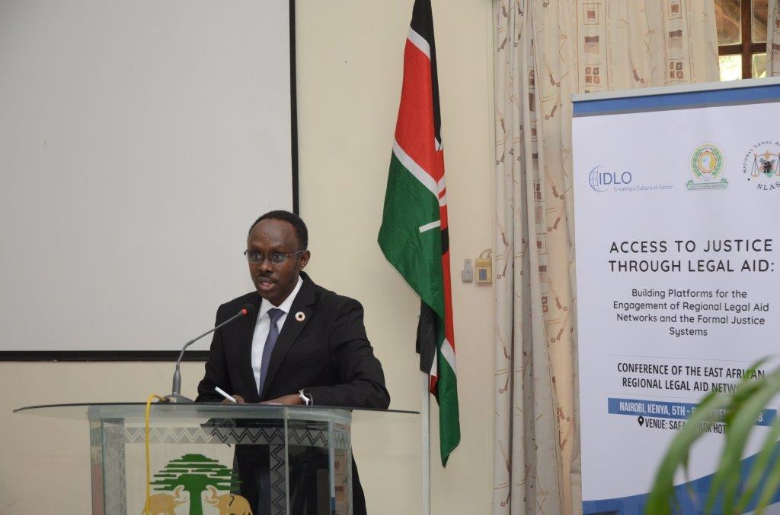

The panel discussion addressed two main issues relating to effective and quality legal aid service delivery, drawing on experiences from state and non-state agencies from the Southern Africa region. The first panelist, Dr Jerry Makokoane discussed the mechanisms for promoting policy dialogue on regulatory reforms for legal aid service, focusing on the quality assurance system adopted by Legal Aid South Africa while the second panelist, Mr. Clifford Msiska, gave a practical example of the Role of Malawi’s Paralegal Advisory Services Institute in ensuring effective and quality legal aid delivery systems.

The Legal Aid South Africa Quality Management Programme is a comprehensive quality management programme, which comprises proactive quality interventions, as well as post monitoring interventions. Under the scheme, all aspects of service delivery are subject to review. According to Dr Makokoane, the Legal Aid SA quality assessment methodology is focused on developing high quality standards for all the four elements that comprise the role of legal aid practitioners, namely, consultation and advisory services, case preparation, case presentation and file administration. Each element is allocated a weighted score of 25%, which add up to 100%.

The institution takes into account the different levels of experience of the legal aid practitioners engaged in various court levels, including district courts, regional courts, the High Court and the Constitutional Court. To ensure acceptable standards of service delivery, the allocation of cases to legal practitioners is informed by, among other things, their level of experience and the type of cases. In effect, complex matters are assigned to more experienced practitioners.

In addition, the in-house case management system enables the institution to keep track of cases before courts, including the number of cases handled by individual practitioners, and the expected turnaround time. The pre-evaluation exercise assesses pending matters in order to ensure that cases that have exceeded their anticipated turnaround time are expedited and resolved within a reasonable time. The post-evaluation assesses whether practitioners have met the quality standards set against the afore-cited indicators. In addition to the foregoing, Legal Aid SA places emphasis on case management and internal self-evaluation, peer to peer evaluation, and independent evaluation from external players. The call centre is subjected to quality assurance with calls recorded and evaluated quarterly by competent legal practitioners.

Mr Clifford Msiska decried the inadequacies of some of the legal aid models that rely almost entirely on lawyers in total disregard of paralegals. In Malawi, paralegals play a critical role in facilitating access to justice by a diverse range of clients. Their areas of operation include courts, prisons, police cells, and local communities. Their basic legal advice and assistance are responsive to the needs of poor clients, who cannot afford legal services on commercial rates charged by practising advocates.

In Malawi, paralegals help inmates and remandees with bail application and other legal procedures. To facilitate this programme, PASI has developed standard bail and appeals forms for use by inmates and remandees. Paralegal interventions in police cells include legal empowerment, helping accused person apply for police bail, and helping children in conflict with the law to have their parents traced. Paralegals also help accused persons and witnesses understand court processes and procedures. Mr. Msiska noted that use of paralegals is the best alternative for any legal aid scheme, as it ensures affordability and accessibility of legal services. In conclusion, he underscored the instrumental role of paralegals in supporting the successful legal challenge to the constitutionality of the death sentence under the Malawi Constitution of 1994. To this end, paralegals visited communities and conducted mitigation interviews which were critical in the final determination of the constitutional reference. Out of the 500 death row cases, 121 were re-sentenced and released immediately, while 28 were given fixed terms.

A key issue that emerged during plenary discussion is the scope of legal aid services in civil matters. Mr. Msiska explained the role that paralegals play in civil legal aid and underscored the fact that there is little or no distinction between civil and criminal cases in the context of the communities in which paralegals have proved invaluable. According to him, matters that are initially considered to be civil disputes may end up as criminal offences. In the formal justice system, paralegals request courts to refer petty offences for mediation. On the other hand, village mediators are trained to identify and refer cases of gross violation of human rights to formal justice systems. He also clarified that the strategic partnership between lawyers and paralegals is key to effective legal aid service delivery.

Dr. Makokoane explained some of the measures that have been put in place to increase interventions in civil matters, especially in the face of dwindling budgetary allocations. He observed that the impact litigation unit has pursued several public interest cases as a way of maximizing returns in civil cases. With regard to the structural arrangements, legal aid SA has posted 2 legal practitioners specializing in civil matters to each local office. He also pointed out measures that have been put in place to ensure that internal evaluation is adequately complemented by robust external evaluation processes. The creation of the legal quality unit, which operates outside local offices and reports directly to the CEO, is suitably designed to enhance the integrity of the quality assurance programme. Under the process, managers seek views and feedback from presiding officers. In addition, Legal Aid SA conducts periodic client-perception surveys through external partners.

In conclusion, Dr. Laibuta urged participants to reflect on how communities dealt with criminal and civil cases before colonization and do what they can to harness good practices from community justice systems. He also challenged them to develop programmes that can fill gaps identified by communities notwithstanding the absence of defined legal and regulatory frameworks.

8.3 Legal Aid in the Context of Vulnerable and Special Interest Groups –Challenges and Opportunities

List of Panelists
Name | Designation | Country
Mr. Joseph Saitoti Njenga | County Executive | Kenya
Mr. Bechir N’Daw, | UNAIDS
Mr. Francis Maina | GJLOS | Kenya
 | Moderator
Dr. Ruth Aura, | Lecturer, Egerton University | Kenya

Mr. Joseph Saitoti Njenga and Mr. Bechir N’Daw shared experiences on the challenges and opportunities for legal aid service delivery to persons with disabilities and persons living with HIV and AIDS respectively. Mr. Francis Maina shared insights into the Governance Justice Law and Order Sector (GJLOS) programme in supporting the establishment and financing of the national legal aid scheme in Kenya.

Mr. Saitoti Njenga highlighted the various historical approaches to addressing disability in society, including the medical model of disability, the charity model, the social model, and the rights based approach. The rights based approach is a radical shift from other models. The rights based approach does not perceive persons with disability as objects of pity or derision but, seeks to empower them to assert their rights as human beings with equal opportunities. He drew the delegates’ attention to Article 54 of the Constitution of Kenya, the United Nations Convention on the Rights of Persons with Disabilities (UNCRPD), and other international and regional human rights instruments, which accord persons with disabilities equal opportunity to access justice. However, lack of good will among the duty bearers, lack of awareness on the rights of persons with disabilities undermine their right of access to justice through legal aid. He called on all stakeholders to confront challenges facing PWDs as their responsibility in order to promote access to justice through legal aid for PWDs.

Mr. Francis Maina gave a brief overview of the GJLOS programme, a sector-wide approach to government resource management. He expressed concern at the lack of prioritization of legal aid services in government development blue prints, such as the Sessional Paper No. 10 of 1966, Vision 2030, and the Big Four Agenda. In his view, stakeholders do well to concentrate on alternative sources of funding, such as non-state agencies and development partners while sensitizing policy makers and legislators on the need to provide adequate budgetary allocation to support the national legal aid scheme. He lauded the role of Kenya’s National Legal Aid Services (NLAS) in promoting access to justice for the poor and challenged stakeholders to aim at making an impact in their interventions in order to attract state funding and financial support from development partners.

According to Mr Bechir N’Daw, UNAIDS supports countries to recognize the importance of legal services in their response to HIV and broader health issues. It also supports capacity building in areas relevant to their mandate and the scaling up of services, which include treatment and legal services. He emphasized the fact that legal aid services for marginalized and special interest groups is critical for them to (a) access housing and other basic services;(b) enforce property and inheritance rights; and (c) access employment without discrimination. Accordingly, it is important that marginalized groups access legal services in an environment that does not focus on penal sanctions targeting their lifestyle. To this end, UNAIDS works with governments to ensure that criminalized population groups access legal aid so as to assert their fundamental right to protection from discrimination.

Access to legal services by vulnerable and marginalised groups is critical to their protection from discrimination in accessing health services. Intervention in the area of human rights is required to reconcile international human rights norms and standards with local traditions and cultural practices. Mr. N’Daw suggested the following measures for improving access to legal services, namely,(a) the training of lawyers in universities on the fundamental right of access to justice through legal aid;(b) reforming the mode of legal aid service delivery models and their applicability in different country-specific context; and (c) enhancing resource mobilization strategies to increase government funding for legal aid.

In plenary, Mr. Saitoti drew the delegates’ attention to Article 8 of the UNCRPD, which creates an obligation on state and non-state actors to create awareness on the rights of PWDs. Kenya has made significant gains in that respect. He underscored the need for awareness creation among the duty bearers. He also concurred with David Holmes’ suggestion on the need to prioritize interventions for persons with mental health challenges and psychosocial disorders.

Ms. Gertrude Angote shared the experience of Kituo Cha Sheria in lobbying for increased budgetary allocations for persons with albinisms. She underscored the need for targeted lobbying and advocacy with the parliamentary budget committees. As a result of Kituo Cha Sheria’s advocacy in 2010, parliament allocated USD 100,000 for sunscreen for persons living with albinism.

Francis echoed the need for advocacy at the policy level for increased budgetary allocation in support of a national legal aid service. He noted that, in many countries, the budgetary processes are not programme-based, which explains why national budgets are not responsive to relevant policy concerns.

8.4 Presentation of the Kenya National Legal Aid Network Needs Assessment Tool
Dr K. I. Laibuta presented an overview of the draft Kenya National Legal Aid Network Needs Assessment Tool. The objectives of the assessment were to identify the main hurdles facing the national legal aid service delivery and to generate recommendations for improvement towards enhancing access to justice through legal aid. The data generated from the assessment will inform the development of appropriate programmes to address the needs of the national network of legal aid providers. He invited participants to review and submit their input and feedback on the needs assessment tool. The questions which the participants were expected to address include:
(a) What can be done to improve the legal and institutional framework for legal aid in Kenya?
(b) What should be the scope of legal aid in both criminal and civil matters?
(c) To whom should the legal aid scheme be accountable?
(d) What is the extent to which the regulatory framework should address eligibility and accreditation of legal aid service providers without shutting doors to key stakeholders, such as paralegals?

The tool was also designed to draw comments and recommendations on, among others, matters relating to –
(a) The cost of litigation and representation
(b) Accessibility of judicial institutions
(c) The extent to which marginalized groups are disadvantaged
(d) The need for collaboration with non state agencies
(e) The sustainability and impact of legal aid services
(f) The ideal legislative, institutional and administrative framework for an effective legal aid scheme
(g) Financial resources
(h) Human resource capacity

8.5 Innovations in Legal Aid Delivery and Sustainability

List of Participants
Name | Designation | Country
Getrude Angote | Kituo cha Sheria | Kenya
Julius Munthali | Governance Expert | Malawi
Sylvia Namubiru | C.E.O, Uganda Network for Legal Aid Providers, | Uganda
Dave Holness | Community Justice Center | South Africa
Mr. Langa Mtshali | National Alliance for the Development of Community Advice-(NADCAO) | South Africa
 | Moderator
Okech Owiti, | Law Lecturer, University of Nairobi | Kenya

Panelists representing legal aid service providers from Kenya, Malawi, Uganda, and South Africa highlighted various innovative approaches employed by their organizations to ensure sustainability of legal aid service delivery. Kituo cha Sheria, a legal aid public benefit organisation based in Kenya uses pro-bono lawyers and paralegals to promote access to justice through legal aid. Kituo has harnessed technology by applying mobile platforms for legal aid services, such as M-Haki, and implements community and prison based paralegal justice centres. Ms. Gertrude Angote, from Kituo Cha Sheria, described the operations of the M-Haki mobile platform that supports advisory services for Kituo’s clients. This mobile platform is funded by the Dutch Embassy and was launched in March 2016 on a pilot basis. By the end of 2017, the project had served 4,670 clients and registered 97% client satisfaction level.

Kituo cha Sheria has also partnered with the Judiciary to implement alternative justice system project in local communities. Under this project, the organization has been instrumental in resolving property disputes arising from the 2007-2008 post-election violence using councils of elders and community leaders. In addition, Kituo partnered with the French Embassy to implement a project designed to equip domestic workers and survivors of sexual violence in Nairobi with business skills. It is such project-specific interventions that yield incremental gains and gradually build up into sustainable programmes.

In conclusion of her presentation, Gertrude highlighted a number of lessons from UK’s state-funded legal aid scheme, which serves as a beneficial example and informs similar schemes in Africa. The UK scheme places emphasis on mediation. Under the scheme, petty crimes are dealt with amicably – without recourse to litigation. UK has also implemented alternatives to legal aid, such as fixed-fee arrangement, which benefit economically disadvantaged consumers. She recommended the use of technology to improve access to justice. She called for increased budgetary allocation to support the national legal aid schemes, and reiterated the need to motivate and incentivize lawyers to take up pro bono cases.

Julius Munthali, a governance expert from Malawi, underscored the fact that there is no one-size-fit-all legal aid delivery scheme. He shared his perspectives on Malawi’s state-funded legal aid scheme administered by Malawi’s Legal Aid Bureau and the donor-funded justice and accountability programme. The justice and accountability programme supports the Legal Aid Bureau in civic education and awareness, village mediation, and paralegal projects. The National Legal Aid Coordination Committee monitors the provision of legal aid services at the national level. The bureau enjoys support from such development partners as the EU, DFID, and UNDP, all of whom sign cooperation agreements with state and non-state agencies in the justice sector dedicated to legal aid. The police, the prisons department, and the Judiciary, are included in donor-funded programmes designed to promote access to justice. Mobile courts (also known as camp courts) sit in prison centres where paralegals assist the courts in clarifying issues during the trial. Even though paralegals provide legal advice and assistance, they do not appear in court in defence of accused persons.

In Uganda, legal aid innovations include (a) the engagement of pro bono duty counsel in magistrates courts;(b) the justice for children programme;(c) public-private partnership with local governments;(d) the use of information management systems;(e) the barefoot law project; and (f) legal aid clinics administered by law students. According to Ms. Sylvia Namubiru, of Uganda Network for Legal Aid Providers, legal aid providers partnered with Rengo Council, one of the local authorities in Uganda, to provide legal aid services in the local community. The council has a budgetary allocation to support the joint legal aid programme. The group of legal aid providers developed a “crowd-funding” software to raise money to support the legal aid programme in the community.

Dr. David Holmes, of the University of Kwa Zulu Natal Law Clinic’s Community Law Centre, underscored the need for a multifaceted approach to legal aid service delivery in order to promote access to legal aid in civil matters through such approaches as post-graduate community service and the engagement of community-based paralegal service scheme. According to him, community-based paralegal support programmes should be adequately resourced. In addition, the paralegals should be trained and incentivized to provide effective legal aid services.

Dr. Homes expressed the view that the post-graduate community service programme allows the students to demonstrate their social responsibility by giving back to society. Their engagement complements the law school legal aid clinics, the pro bono lawyers, as well as the non-governmental organizations providing legal aid services. He encouraged the delegates to ensure high quality legal aid services and avoid mediocre service delivery simply because the beneficiaries do not pay for the service.

To conclude the session, Mr. Langa Mtshali of the National Alliance for the Development of Community Advice (NADCAO) of South Africa shared his country’s innovations designed to expand the scope of community advice centres under the coordination of NADCAO. He drew the delegates’ attention to the fact that, in South Africa, the Legal Practice Act 2014 entrusted the Legal Practice Council with the responsibility of establishing a self-regulating framework for paralegals working in various community-based organizations.

Stakeholders in South Africa’s legal aid sector are drafting a Bill to regulate the engagement of paralegals. In order to sustain the work of community advice organizations, NADCAO supports the concept of basket funding by development partners and governments. To ensure effective coordination of the programme, NADCAO has taken steps to harmonize case tracking to address the perennial challenge as different organizations use different models for tracking cases. To upscale the gains, NADCAO envisages the creation of an African Centre of Excellence on Access to Justice suitably designed to advocate for state-funded legal aid and coordinate the attainment of universal standards of quality legal aid service delivery in the continent.

During the plenary session, Kituo Cha Sheria reported that the Kenya Pro Bono Lawyer of the Year Award encourages lawyers to provide pro bono legal services. Kituo is presently working on a similar award scheme for paralegals – the Paralegal of the Year Award – and on the proposed annual paralegal summit. Other innovations include (a) court users committee meetings where paralegals participate and make presentations; (b) partnership development with university law schools; (c) regular mobile aid clinics designed to create legal awareness and empower communities; and (d) holding annual legal awareness week in collaboration with the judiciary. Gertrude also noted that the M-Haki mobile service response window of 48 hours has worked well due to the ability of Kituo cha Sheria to tap into its large network of pro bono lawyers, ICT experts, quality control coordinators, and knowledge management experts. She explained that more personnel is required to meet the rising demand when the project is rolled out to the public following the successful conclusion of the pilot phase.

Sylvia explained that, in Uganda, the partnership between legal aid service providers and local authorities is anchored on a memorandum of understanding made between the Council and FIDA-Uganda, the legal aid service provider, The Council supports FIDA and provides a vehicle for community outreach. Uganda has no state funded legal aid. However, the Council makes budgetary provisions for legal aid in each District. Since donor-funding is limited, FIDA agreed with the Council that communities make financial contributions towards the legal aid scheme. This is the genesis of the crowd-funding, a web-based software launched in August 2018.
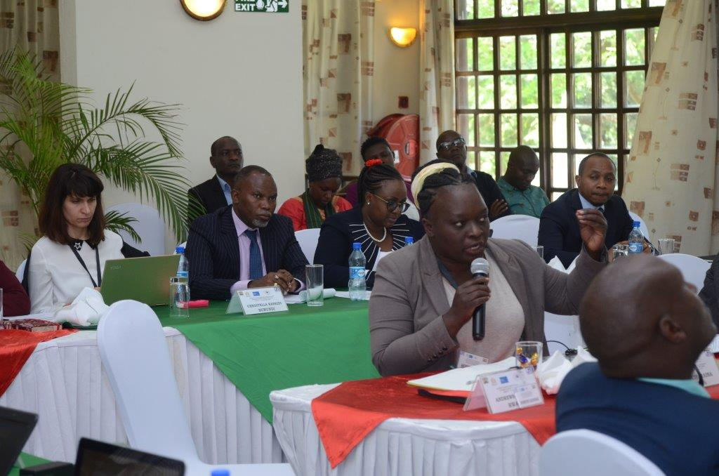

8.6 Focus Group Discussion - Mapping the Way Forward Toward the East Africa Regional Legal Aid Network
The final session of the day was a focus-group discussion among a select number of representatives of the regional legal aid service providers. The group discussion was intended to map the way forward towards the creation of the proposed East Africa Regional Legal Aid Network. The delegates resolved to establish a regional network of legal aid service providers to be known as “the East African Legal Aid Network.” The overall goal of the network shall be to promote and protect the right of access to justice through legal aid. In addition, the delegates agreed that each member shall cooperate and collaborate with others in the attainment of the objectives of the Network, and take responsibility for their individual financial obligations. They undertook to meet the logistical expenses on account of meetings and provide logistical support for the realization of the main objective of the Network.

The delegates defined the networks core values and guiding principles, as well as its proposed institutional and administrative structure. The administrative structure comprises a two year rotating chairperson and secretariat, which shall coordinate the network. Other issues discussed during the meeting include frequency of meetings, reporting requirements, records management, office equipment, financial arrangements and engagement with strategic partners. It was resolved the Kenya’s NLAS shall be the first institution to host the network. A draft memorandum of understanding shall be circulated among the members of the Network for signature. Finally, it was resolved that membership shall be open to both state and non-state agencies in each country. The founding members are –
- Burundi – the Min of Justice and the Bar Association of Burundi
- Kenya – the National Legal Aid Service and the Paralegal Support Network
- Rwanda – the Legal Aid Forum and the National Legal Aid Committee
- Somalia – Min of Justice and the Bar Association
- South Sudan – the South Sudan Bar Association and the Ministry of Justice
- Tanzania –the Tanzania Network of Legal Aid Providers and the National Legal Aid Advisory Board
- Uganda – the Legal Aid Providers Network and the Justice Center
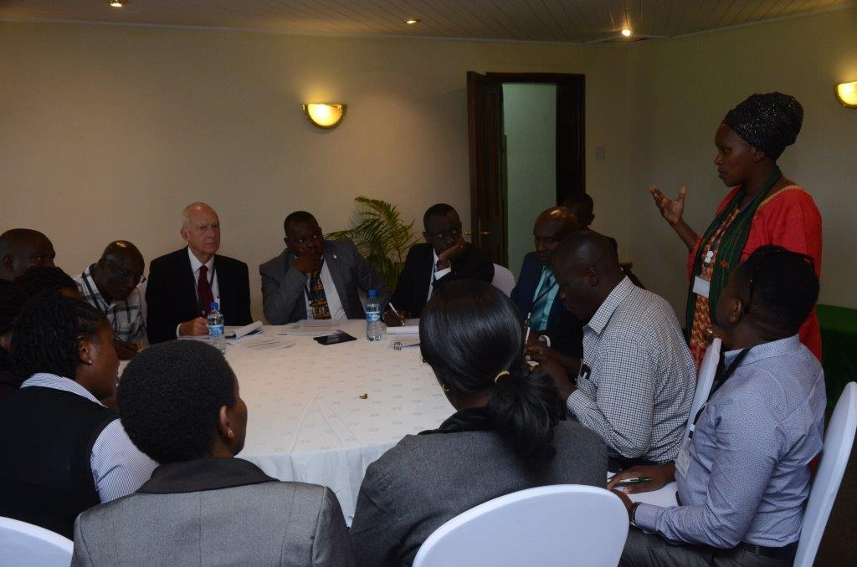

9. DAY 3: 7TH NOVEMBER, 2018

9.1 Introduction
On the third day, the combined sessions brought together the legal aid providers and members of the East African Judicial Education Committee to share experiences from the regional judicial institutions and other state and non-state agencies in the justice sector on matters relating to legal aid.
The combined sessions addressed four main issues, namely, (a) the role of legal aid in advancing the right of access to justice; (b) comparative and institutional frameworks for legal aid delivery; (c) judiciary experience with legal aid; and (d) experience on informal justice systems in dispensing justice. The first combined session commenced with the keynote address by Hon. Justice Philip N. Waki, Judge of Appeal, Kenya, on the role of legal aid in access to justice. Justice Waki’s speech was made on behalf of Hon. Justice William Ouko, President of the Court of Appeal, Kenya. In attendance was the Hon. (Rtd) Justice Willy Mutunga, the former Chief Justice of the Republic of Kenya.

9.2 The Role of Legal Aid in Access to Justice
Keynote Speaker – Hon. Justice Philip N. Waki (Judge of Appeal, Kenya)
Moderator – Hon. Justice Dr. Henry Peter Adonyo (Executive Director, Judicial Training Institute, Uganda)

In his keynote address, Justice Waki acknowledged that the concept of access to justice is wide. A broad definition of the concept was provided by the court in the Kenyan case of Dry Associates Ltd v Capital Markets Authority & Another Interested Party Crown Berger (K) Ltd [2012] eKLR( Petition No. 328 of 2011).The concept includes access to dispute resolution mechanisms that are accessible, affordable and procedurally friendly, as well as access to information and legal representation. Tracing the history of legal aid in Kenya, Justice Waki highlighted some of the challenges that necessitate reforms in the legal aid framework leading to the enactment of the Legal Aid Act in 2016. The Act sought to, among other things, give effect to Articles 19, 48 and 50 of the Constitution of Kenya, and to promote access to justice. Under the old Constitution, legal aid was limited in scope. Pauper briefs were limited to some capital offences in criminal proceedings in the High Court and the Court of Appeal. The Court of Appeal had power to waive court fees in some civil and criminal cases.

Justice Waki cited the Justice Needs and Satisfaction Survey of 2017 by Hague Institute for Innovation of Law,” which revealed that approximately 20 million people in Kenya sought and expected a fair and accessible justice process. It was estimated that by 30 June 2018, 388,000 cases were pending in Court. He argued that equality before the law demands that free legal services be availed in appropriate cases.

Unlike the old constitution, the Constitution of Kenya, 2010 provides that every accused person has the right to fair trial, which includes the right to have an advocate assigned to the accused person by the State, and at State expense, if substantial injustice would otherwise result, and to be informed of this right promptly. This was a major milestone in securing legal aid for accused persons.

The Supreme Court provided clarity on the scope of this provision in the case of Republic v Karisa Kyengo & Others, stating that the right to state funded legal assistance is a fundamental ingredient of fair trial, even though it is not an open ended right. Justice Waki noted that the Constitution and the Legal Aid Act do not expressly define what amounts to substantial injustice. However, section 36 of the Legal Aid Act provides a broad criteria for eligibility for legal aid.

In addition to the foregoing, the Honourable Judge outlined (a) the legal and institutional frameworks set out in the Legal Aid Act;(b) the policy orientation of the National Action Plan on Legal Aid 2017 – 2022; and (c) the measures taken to implement the Constitutional guarantees and the rights conferred by the Act. He drew the delegates’ attention to the Practice Directions issued by the Chief Justice on pauper briefs and pro bono services designed to enhance access to justice. In conclusion, the Judge highlighted the impediments to access judicial proceedings in Kenya’s judicial institutions. He recommended practical interventions to enhance access to justice. These interventions include (a) the implementation countrywide of the Court Annexed Mediation programme, which is presently at its pilot phase;(b) the establishment of the Task Force on Alternative Justice System as part of the range of measures designed to encourage the use of ADR; and (c) the implementation of the Small Claims Courts, which exclude representation by legal counsel, a statutory measure designed to expedite proceedings and make the judicial process accessible to ordinary citizens.

During the ensuing plenary session, Justice Waki updated participants on the status of the Judiciary Fund (which is not yet operational) and expressed the view that, once the Fund is operationalised, the Judiciary would be well placed to allocate funds to legal aid. He also outlined some of the measures that the judiciary in Kenya has taken to create awareness on legal aid. The Judge drew the delegates’ attention to the fact that some of the legal aid service providers are active members of the multi-stakeholder Court User Committees throughout the country, and whose mandate includes the promotion of access to justice.

9.3 Comparative and Institutional Frameworks for Legal Aid
List of Presenters
Name | Designation | Country
Justice Kathurima M’Inoti, | Judge, Court of Appeal and Director Judicial Training Institute, | Kenya
Ted Hill | Senior Legal Advisor-Program Development-IDLO | Italy
 | Moderator
Mr. Edouard Minani, | Head, Professional Training Center of Justice | Burundi

The Hon. Justice Kathurima M’Inoti presented a comparative study of three models of legal aid service delivery in three different jurisdictions, namely, Kenya, Tanzania and Zimbabwe. Before the promulgation of the 2010 Constitution in Kenya, the legal aid service delivery model was largely spearheaded by civil society organizations and the Law Society of Kenya, with minimal state intervention. This is because the repealed Constitution did not guarantee the right to legal representation at the state expense. Since 2010, Kenya has adopted a state-funded legal aid service delivery model founded on the 2010 Constitution and the 2016 Act, which provide for legal aid services in both criminal and civil matters.

The National Legal Aid Service administers the national legal aid scheme. On their part, judicial officers have a duty to inform parties to proceedings of the existence of legal aid services, and may call on NLAS to facilitate legal representation to persons engaged in proceedings before the court. However, the scheme is not fully operational due to financial constraints. Notwithstanding the financial challenges, the Judge lauded the state-funded scheme as a clear demonstration of the State’s recognition of its constitutional obligation to facilitate equal access to justice. Under the scheme, NLAS has power to enter into partnership with legal service providers and development partners who have a stake in the justice sector to facilitate legal aid delivery. In this regard, NLAS may receive grants, gifts and donations from lawful sources, and to petition the Cabinet Secretary responsible for finance to grant tax rebate or waiver to institutions that make financial contribution to the scheme.

Like Kenya, Zimbabwe has a state-funded legal aid service delivery model. The Legal Aid Act 2016 established the Legal Aid Directorate and the Legal Aid Fund. However, the provision of legal aid services is subject to the discretion of the director who applies a means test and considers the availability of financial resources to support the particular services sought by the applicant. There are concerns over the Director’s independence due to the fact that they are subject to policy direction of the Minister responsible for legal aid. On the other hand, the Director’s discretion is rather wide, even though they only engage government-approved lawyers.

The Judiciary in Zimbabwe plays a significant role under the scheme. Judicial officers may require the Director to provide legal aid to an indigent person appearing in court. The Legal Aid Fund is financed through appropriation by Parliament, charitable donations and contributions, contribution by beneficiaries under the scheme, and retention of a percentage of sums recovered in civil proceedings involving beneficiaries of the scheme.

In the United Republic of Tanzania, legal aid service provision is supported by (a) various civil society organizations;(b) the umbrella body – the Tanzania Network of Legal Aid Providers;(c) the Tanzanian Law Society; and (d) the legal aid Clinic of the University of Dar-Es-Salaam.

The Legal Aid Act, 2017 creates the institutional and administrative frameworks for recognition and regulation of legal aid service providers in Tanzania. The National Legal Aid Advisory Board provides policy direction while the Office of the Registrar is responsible for the registration of service providers. In addition, the Registrar receives and investigates complaints lodged against the legal aid providers, and sets the minimum qualifications for their registration. Application for provision of legal aid is in accordance with the internal rules of the respective service providers. In criminal matters, judges and magistrates may certify cases for legal aid. Fees for services are paid out of the Judiciary Fund. In civil matters, beneficiaries of the scheme are not required to pay costs.

Justice M’Inoti drew the delegates’ attention to the fact that the Tanzanian legal aid delivery model is largely concerned with the regulation of legal aid service providers and, but not with the obligation to provide legal aid at the state expense in both civil and criminal matters. The Hon. Judge concluded his presentation by calling for increase public-private partnership as the only viable way of ensuring sustainability of legal aid schemes. He underscored the fact that non-state agencies have a critical role to play in the face of underfunding of state-sponsored legal aid schemes.

In plenary, Justice M’Inoti raised concern over the proposed tax incentives for legal aid providers, which some argue that it poses the risk of reducing the public kitty and, in turn, impact negatively on the delivery of other public services. According to him, such incentives do not reduce the public kitty. To the contrary, they attract increased funding in support of the Legal id Fund. According to him, it might not be practical to recommend a standard model for adoption by each Member State because the country-specific context determines the appropriate model. However, there are fundamental ingredients for an effective legal aid scheme, which include transparency, professionalism in the management of the scheme, and independence. In his opinion, a middle ground may be struck between a mandatory legal aid scheme and one in which legal aid is available in all cases where substantial injustice would otherwise occur.

Mr. Ted Hill highlighted the challenges arising from the extension of legal aid to civil matters in the face of inadequate resource base, which compels national schemes to prioritise criminal matters. According to him, legal aid should be available in both civil and criminal matters. Furthermore, the right of access to justice cuts across the board, and is not restricted to a particular legal discipline. He underscored the fact that access to justice and legal aid in civil matters plays a critical role in maintaining peace and harmony. He expressed the view that some disputes that are initially perceived as civil often escalate into criminal cases. Examples include land, succession or marital disputes that often lead to assault or homicide.

In his concluding remarks, Mr. Hill was quick to point out that legal aid in civil matters facilitates the realisation of sustainable development. He recommended the establishment of criteria for determining eligibility in civil cases, such as (a) the means test;(b) the type of case – whether claimant or defendant is more entitled to legal aid;(c) prioritising cases involving fundamental human rights and freedoms of the individual; (d) prioritizing family disputes; and (e) supporting public interest litigation in strategic cases whose outcomes impact on society as a whole, as opposed to benefits that accrue to individual litigants. He underscored the importance of ADR in legal aid.

In the ensuing plenary session, the delegates acknowledged the importance of legal aid in civil matters, such as land and labour disputes that have a direct impact on our social-economic environment. It is these kinds of disputes that pose the risk of escalation into criminal conduct.

9.4 Judiciary’s Experience with Legal Aid
List of Panelists
Name | Designation | Country
Lady Justice Dr Mary Caroline Levira, | High Court Judge | Tanzania
Justice Emmanuel Baribarida | Judge Court of Appeal Burundi, Deputy Director Professional Centre of Justice | Burundi
Hon Justice Francois Regis Rukunda | Inspector General Court of Judicature  Commissioner, Law Reform Commission | Rwanda,
Hon Dr Henry Adonyo | High Court Judge | Uganda
Justice Francis Amum Awin Ayoker, | High Court Judge | South Sudan
Dr Steve Ouma | Deputy Director , Judicial Training Institute | Kenya
 | Moderator
Florence Ochago | Principal Legal Officer, EAC | Uganda

Judicial officers from Burundi, Kenya, Rwanda, the Republic of South Sudan, the United Republic of Tanzania, and Uganda, shared their experiences with legal aid service schemes in their respective jurisdictions. According to Lady Justice Dr Mary Levira, legal aid in Tanzania is mainly administered by civil society organizations most of whom rely on donor-funding with limited state funding. The Tanzanian Legal Aid Act, 2017 has extended the scope of legal aid service beyond serious offences to include both civil and criminal matters. However, there has been no budgetary allocation or specific public fund established to implement the law.

The law on legal aid in Tanzania is guided by five principles, namely, accessibility, credibility, sustainability, affordability, and accountability. With regard to accessibility, prisoners and persons held in custody have access to legal aid from the point of arrest through trial. The law requires legal aid providers to have the necessary knowledge, qualifications and skills, to provide legal aid. In this regard, the Legal Aid Advisory Board and the Registrar play a crucial role in setting and enforcing quality standard for legal aid service delivery. The law establishes a Legal Aid Fund, which is not yet operational.

With regard to accountability, the law has defined various offences and prescribed stiff penalties against legal aid service providers and any person guilty of misappropriation of funds, charging fees, and impersonation. She called on the state to make budgetary allocation towards a fully operational legal aid scheme.

Justice Emmanuel Baribarirra highlighted the challenges facing legal aid service delivery, which has for a long time been the preserve of civil society organizations. Happily, though, Member States have lately taken an interest in providing and coordinating service delivery. Even though the policy, legislative and administrative frameworks in most countries are not comprehensive, constitutional law, criminal law and the law relating to gender-based violence contain provisions on legal aid. He noted that Burundi’s National Legal Aid Strategy provides basic guidelines on eligibility for legal aid. The main challenges facing legal aid service delivery in Burundi include funding, lack of legal awareness, shortage of lawyers, and the limited geographical reach.

The delegates heard that Rwanda has no comprehensive national legal aid scheme. According to Justice Francois Regis Rukunda, the Ministry of Justice, Bar Associations and Civil society organizations provide legal aid services in Rwanda, Legal aid is mandatory in the Supreme Court, the Court of Appeal, as well as in cases involving minors in conflict with the law. He highlighted the opportunities for expanding the scope of legal aid, which include the use of local language in dispute resolution, and promoting the use of ADR at the community level.

The Hon. Justice Dr. Henry Adonyo observed that legal aid service delivery is minimal and ineffective in Uganda. It remains in the hands of non-state agencies with limited coordination. The quality and level of representation is low due to poor remuneration of individual lawyers and paralegals engaged in the programmes. Legal aid in Uganda is administered under the state brief schemes, the Justice Centre’s Programme, programmes implemented by civil society organizations and paralegals. Law students in the Law Development Centre also provide legal aid under supervision by senior lawyers. However, these interventions have not yielded significant gains. In order to strengthen legal aid service delivery, he recommended that research should be undertaken to unpack legal aid and relate it to African culture of dispute resolution, the State should provide legal aid in the fullest sense without undue limitations, much like the all-familiar universal healthcare and basic education. He also called for inclusion of traditional and cultural mechanisms to resolve disputes so as to harness the benefits of alternative justice systems in local communities. By doing so, access to justice will be people-centred, as opposed to the current practice where the people are reduced to mere consumers of legal services.

In South Sudan, Article 19(7) of the Transitional Constitution and other laws, including the Labour Act, provide the legal framework for legal aid. According to Justice Awin Ayoker, legal aid is available as a matter of right in serious offences. Courts are also empowered to waive payment of fees in labour disputes. Various state and non-state agencies provide legal aid services, including the Ministry of Justice and civil society organizations. Legal aid is available in both civil and criminal cases. In addition to legal advice and representation, courts have the discretion to waive court fees in cases where the applicant meets the eligibility criteria. He concluded by recommending the enactment of a comprehensive policy and legal framework for legal aid.

In his assessment of the legal aid model in Kenya, Dr. Steve Ouma noted that the Justice Needs and Satisfaction Survey, 2011 revealed that 80% of disputes in Kenya are settled through alternative justice systems, most of which are community-based. Less than 20% find their way into the conventional judicial system. Dr. Ouma observed that legal aid is intricately linked to the formal justice system, particularly in relation to criminal justice in which only a few members of the society are involved. On the other hand, users of alternative justice system do not require legal aid. In his view, the major challenge in legal aid service delivery is the obvious bias towards providing legal aid in the formal criminal justice system at the expense of civil disputes from which many criminal cases arise. Further, legal aid is tied to courts and legal counsel, thus acquiring an “urban phenomenon” with the effect of locking out rural and other outlying communities. He called for measures to ensure that average citizens are able to access justice through legal aid. He also questioned the quality of service offered by pro bono lawyers and observed that many competent lawyers shun legal aid programmes. He called for the integration of legal aid curriculum in universities and law schools, and ensuring an inclusive approach towards providing legal services beyond the agency of a lawyer.

In plenary, the delegates reiterated the need to avoid using derogatory words in provisions relating to legal aid services. They recommended the use of the words “poor” or “needy” in place of “indigent”. The delegates acknowledged the need to address the quality of legal aid service and competency of lawyers providing pro bono services.

9.5 Experiences on Informal Justice Systems in dispensing justice
List of Panelists
Name | Designation | Country
Hon Justice (Prof) Joel Ngugi, | Chairperson, AJS Taskforce | Kenya
Hon Justice Dr Bak Deng, | Directorate of Training and Research | South Sudan
Dr Kayihura M Didas | Director of the Institute of Legal Practice and Development (ILPD) | Rwanda
Hon. Justice Ann Williams, | Jones Day USA | USA
Mohamed Abdillah Qablan | Attorney General’s Office | Somalia
 | Moderator
Hon Justice Elinaza Luvanda, | High Court Judge | Tanzania
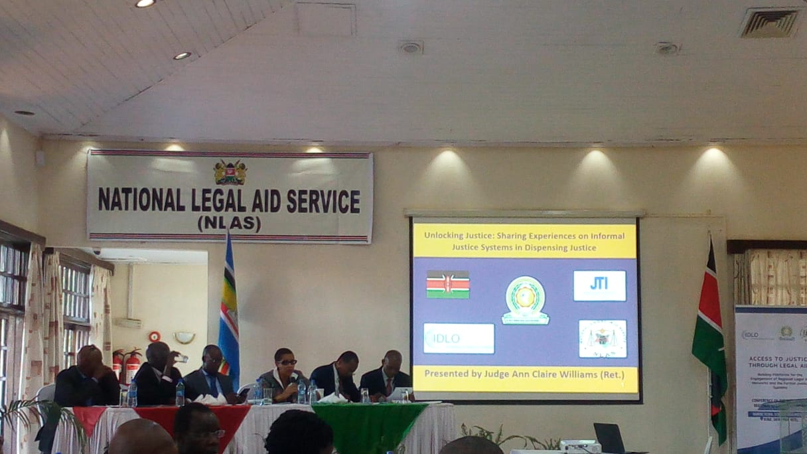
During the final session of the day, judicial officers from Kenya, South Sudan, Rwanda, United States of America and Somalia, shared their experiences with informal justice systems and the critical role played by these systems in the justice system.

Justice Joel Ngugi observed that Kenya inherited an imposed formal legal system without questioning its depravity. The system did not consider that justice was not primarily the preserve of the conventional judicial institutions. He observed that use of alternative dispute resolution is a constitutional imperative under article 159 of the constitution, which recognizes traditional dispute resolution mechanisms as an integral part of dispute resolution as a guiding principle thereof, in addition to other constitutional dictates.

The rationale for alternative justice system includes its effectiveness and efficiency, as confirmed by the findings of the Justice Needs and Satisfaction Survey alluded to earlier in the report. In addition, alternative justice systems reduce congestion and backlogs as well as the rates of detention in remand and prison. In his schematic presentation of the river of justice, he observed that courts are at the narrow end of the river, so to speak, handling very few disputes. In many cases, courts lack competence to address customary law disputes, which are ideal for AJS. He highlighted various categories of AJS providers that include court-annexed AJS system, such as the diversion programme piloted in courts in Isiolo, Othaya, Kangema and Kericho in Kenya. There are also third party institutions annexed programmes, autonomous AJS system created and regulated by the state and unregulated AJS. The key questions that need to be addressed before implementing an AJS programme are the jurisdiction and vulnerability of such mechanisms, the types of cases that may be referred to AJS, and the role of public prosecutors before such forums. Questions also arise, with respect to the protection of vulnerable groups; as how to respond to traditional and harmful cultural practices, the role of lawyers and paralegals, and the enforcement of the decisions of such forums. Recommending the way forward, Prof. Ngugi called for the adoption of a comprehensive AJS policy, legal and institutional frameworks, and guidelines and standards for the administration of AJS.

Hon Justice Dr Bak Deng informed the members that in South Sudan, Article 173 of the Transitional Constitution, 2011 recognizes customary law justice systems, which bridge the gaps in the formal justice system. The Local Government Act, 2009 establishes customary law courts of various levels and jurisdiction. These courts are empowered to adjudicate over disputes in accordance with the customs and traditions of various communities. Similarly, section 7(2) of the Civil Procedure Act recognizes the application of customary law to resolve disputes not contemplated in statute law.

As experience in South Sudan shows, traditional courts are close to communities in view of the vast geographical area that limits access to conventional judicial institutions. Moreover, traditional courts apply simple procedures, making them more accessible to the ordinary users than are conventional courts. Tribal chiefs intercede in such serious cases as murder, and intervene inter-communal fighting that cannot be tried in formal courts. 90% of South Sudan’s caseload was determined at the level of village chiefs. However, the prevailing political instability has impacted negatively on customary law courts. Chiefs in tribal areas have been threatened and often intimidated. In some cases, they have been arbitrarily relieved of their traditional authority.

Dr Kayihura M Didas shared the experience of Rwanda, where the outbreak of violence in 1994 led to the collapse of the formal judicial system. When state authority was restored, Rwanda experimented with the Gacaca system and revived the age-old traditional dispute resolution system “under a tree”. According to Dr. Kayihura, Gacaca courts, which were manned by people not trained in law, achieved what was viewed as impossible .They facilitated reconciliation and restoration of harmonious relations between the hitherto warring ethnic groups in under two years in the spirit of “truth and reconciliation”. Prior thereto, the community had refused to present witnesses in court during the genocide trials for fear of recrimination, but came out in numbers to actively participate in the Gacaca courts. Families of victims who refrained from participating in the court process came forward to freely tell their story in the Gacaca courts, which did not permit legal representation by lawyers.

The Rwanda experience presents invaluable lessons to all – that people have the power to resolve their own disputes. Rwanda is presently experimenting with a different community justice system known as the Abunzi, which is a semi-formal system under which the community elects 7 persons of integrity for a term of 4-5 years to handle civil disputes without pay. More than 80% of disputes are resolved through this system with only 20% ending up in court. Appeals from the decisions of the Abunzi go to the 1st level courts with no right of further appeal. In addition to these initiatives, the Ministry of Justice administers the community-level legal advisory service (Maison d'Accès à la Justice”, MAJ), which helps to settle disputes at the community level.

The Hon. Justice (Rtd) Anne William shared some of the strategies that have been employed in the USA to promote access to justice. She noted that the establishment of Legal Services Corporation in the 1970s was intended to enhance access to justice by providing legal services to those in need, but could not meet the rising demand. According to her, there is need for complementary interventions for the enhancement of access to justice, including(a) the promotion of a pro bono culture among practicing lawyers and in house counsel;(b) encouraging corporations to give financial support towards legal aid;(c) establishing legal aid clinics;(d) establishing post-graduate fellowship programmes to provide pro bono services in the community; and (e) the barefoot law project in USA and select African countries.

Mohamed Abdillah Qablan informed members that in Somalia, customary law is the primary source of law that drives all dispute resolution mechanisms, which are largely community-based. These alternative justice systems are administered by clans, and are designed to serve the needs of local communities. In addition, there are Sharia Courts and magistrate courts, which exercise their judicial authority under Islamic Law and English common law, respectively. Customary law deals with many civil and criminal cases, but serious offences are referred to Sharia courts. Community elders who preside over the traditional courts are entrusted with authority to determine such sensitive cases as the return and reintegration into the community of Al Shabaab defectors. Many of the returnees seek intervention from clan elders rather than from state authorities so as to secure the assurance of clemency and safe return. The traditional justice systems in Somalia have been faced with the threat of being faced out since the onset of colonial administration, during the successive military regimes, and Al Shabaab. Today, clan-based traditional courts have stood the test of time and remain resilient to the delight of local communities.

The plenary session addressed various issues, including the need to incentivize lawyers to take up pro bono cases. The delegates underscored the need for concrete studies on the role of AJS in enhancing access to justice by the majority in local communities. It was also recommended that judicial training institutions and other training centres document and disseminate best practices in judicial innovations and AJS in dispensing justice. Dr. Laibuta called for a paradigm shift from the current system of distributive and retributive justice to a restorative approach to justice through ADR and community justice systems for both civil and criminal matters.

10. DAY 4: 8TH NOVEMBER 2018

10.1 Introduction

The final day of the conference comprised two substantive sessions which were followed by presentations and the adoption of the conference resolutions and the closing session. The first panel session was a presentation by Dr Oketch Owiti clarifying and recontextualizing legal aid and access to justice. This was followed by the discussion by Mr. Paul Kaunda on understanding the role and challenges of legal aid networks in accessing justice in the region. During the second session, the panelists, Dr. K. I. Laibuta and Dr. Jerry Mokokoane, shared their perspectives on the role of state and non-state agencies in building linkages for effective legal aid delivery.

10.2 Recontextualising Legal Aid and Access to Justice
Presenter – Mr. Okech Owiti (University of Nairobi Law School,)
Moderator – Samuel Mohochi (the Executive Director, ICJ and Chairperson of the Paralegal Support Network, Kenya)

Mr. Oketch Owiti argued that, even though access to justice and legal aid are two distinct concepts, the two are often confused as is the definition of legal aid in section 2 of Kenya’s Legal Aid Act. He traced the evolution of the concept of access to justice based on five distinct phases that profoundly influenced the understanding of the concept. In the first phase in the 1960s, access to justice was perceived as legal aid. The second phase in the 1970s focused on legal reforms, primarily the reforms relating to prosecutorial powers while the third phase in the 1980s addressed reforms in courts, advocacy on specific rights, alternative dispute resolution, dispute prevention, restorative and transformative justice, as integral parts of access to justice. The fourth phase of programmes in access to justice took place in the 1990s and focused on holistic advocacy, intensification of ADR and public participation in law making. In the fifth phase that began in the year 2000, there were attempts at connecting the legal system to societal issues.

According to Mr. Owiti, it is only in the 1960s that legal aid was seen as equal to access to justice. However the concept of access to justice is broader than legal aid. According to him the rule of law framework of access to justice and it’s over reliance on the justice system as an avenue for access to justice suffered great shortcomings and needed reforms to address the basic needs of the community. He argued that access to justice as legal empowerment of the poor does not adequately address the roots of property relations and called for a new framework for access to justice and a theory of everything. He proposed an access to justice pyramid with a starting point at legal empowerment, participation, dispute preemption and dispute resolution. In dispute resolution encompasses community based mechanisms, ADR, judicial justice and legal assistance which, in its broad conception, include legal advice. He noted that only 20% of disputes go to court, and fewer disputes require legal aid. Legal aid is significant but a tiny bit in the context of access to justice. In conclusion, Mr. Okech challenged the delegates to continue the search for the appropriate conception of access to justice, and the best model for legal aid in particular.

During the ensuing plenary session, the Bangladesh experience was cited as a case study of people-driven legal empowerment programme (EMCOP). Mr. Oketch Owiti explained that legal aid is legal advice and representation, including referral – by a local chief, an elder or council of elders, a religious leader, an advocate, or by an ADR expert. In his concluding remarks, he observed that legal aid is not an end in itself, creating a better society is the end to which must all aspire.

10.3 Understanding the Role and Challenges of Legal Aid Networks in Accessing Justice at the Regional Level
Presenter – Mr. Paul R. Kaunda (Vice-President of the Eastern Africa’s Branch of the Pan-African Lawyers Union)
Moderator – Samuel Mohochi (the Executive Director, ICJ and Chairperson, Paralegal Support Network, Kenya)

The Pan African Lawyers Union (PALU) offers legal aid to needy applicants in public interest litigation at the East African Court of Justice and the African Court on Human and Peoples Rights. Mr. Kaunda noted that there is no obligation to offer legal aid before the EACJ. However, in article 10(2) of the protocol establishing the ACtHPR, there is a clear obligation to provide legal aid at the African Court on Human and Peoples Rights. However, the African Union has not dedicated resources for legal aid. PALU has therefore taken up the role of providing pro bono legal assistance in cases referred to them by the two courts. He cited examples of some of the cases filed before EACJ and ACtHPR, including Reference No 19 of 2018 against the Government of Southern Sudan – Mohamed Bakari v the United Republic of Tanzania, Niyongabo Sibo v Burundi, and Olosokwane Village Council v United Republic of Tanzania. He cited the high cost of litigation and inadequate funding for legal aid services as one of the main challenges faced by PALU in providing legal aid services.

10.4 Building Linkages for Effective Legal Aid Delivery: the Role of State and Non-State Agencies

List of Presenters
Name | Designation | Country
Dr Kibaya Imaana Laibuta | Consultant, Premier ADR Consultants | Kenya
Dr Jerry Mokokoane | Chief Operations Officer , Legal Aid South Africa | South Africa
 | Moderator
Dr Steve Ouma | Deputy Director , Judicial Training Institute | Kenya

In his presentation, Dr. Laibuta underscored the fact that access to justice is a fundamental right for all, and that it is the duty of the state to provide mechanisms for the realization of that right. Legal aid is one of the most practical means of facilitating the realisation of this right. However, the model of legal aid delivery should be multifaceted and should answer to specific community needs, such as those of pastoralist communities fighting over water points. He urged participants to learn from communities that hardly litigate but prefer to apply their own values and customs to pre-empt and resolve conflicts without intervention of ignorant third parties. Accordingly, there is need for all stakeholders, including legal aid providers to consider the best interventions that address conflicts and disputes at the community level. He proposed development of partnerships among all stakeholders in the justice sector at the national and community levels. According to Dr. Laibuta, it is the people-driven models of access to justice that serve their needs and yield proportionate returns.

Dr Jerry Makokoane discussed Legal Aid South Africa’s approach to building linkages in South Africa, beginning with a stakeholder conceptual framework, which helps in identifying strategic risks in providing legal aid. The next step would be to identify the key agencies that either support or undermine the achievement of the stated objectives. Based on the analysis, stakeholder engagement may be built on five main aspects – information only, consultation group, partnerships, empowerments and collaboration. The concept of justice value chain helps in identifying what is rational and practical. With regard to reporting on performance, Legal Aid SA has an integrated reporting approach and an effective stakeholder engagement, all interested parties are kept informed through a comprehensive issues register, community advice centres, and social development departments. He concluded by sharing a pictorial model on effective stakeholder relationship.

10.5 Closing Session, Conference Resolutions and Recommendations
At the end of the conference, the delegates adopted conference resolutions and recommendations annexed at the end of the report. Representative from partner organizations, including the National Legal Aid Service, the East African Community, EAJEC, and IDLO gave their closing remarks.

Ms. Florence Ochago, the Principle Legal Officer at the EAC Secretariat, observed that the conference deliberations enhanced the delegates’ understanding of the various approaches to legal aid service delivery in the promotion of access to justice. Ms. Ochago lauded the efforts made by various state and non-state agencies in promoting access to justice. She highlighted the challenges relating to geographical coverage, limited funding, and the bias towards legal aid in criminal proceedings, which have undermined effective legal aid service delivery. She recognized the need to embrace alternative justice systems and lend legal recognition to such systems. She urged the delegates to identify appropriate legal aid models that work well in their country-specific context. She expressed her appreciation to the conference organizers and called for continued dialogue and experience-sharing among stakeholders on the need to build effective linkages for effective access to justice.

Mr. Robert Kibor, the Vice-Chairperson of NLAS, expressed his appreciation to the conference organizers. He was gratified by the NLAS’s success in hosting the conference. Mr. Kibor emphasized that access to justice is a fundamental right of vulnerable and minority groups, and that there can be no development without access to justice. He called on the delegates to carry the deliberations beyond the conference with a view of implementing the resolutions and recommendations of the conference.

In conclusion, Mr. Kibor invited Muiruri Ryan, an intersex person, who was born ‘Ruth Wangui’ to share his personal experiences and the stigma he has faced as an intersex in Kenya, including violence and harassment in school, social settings and other public places, due to lack of legal recognition as an intersex.

Mr. Romualdo Mavedzenge, the Kenya Country Director-IDLO, congratulated the delegates and the regional network for the conference outcome, namely, the Nairobi declaration that has led to the establishment of the East African Legal Aid Network. He challenged the Network to move swiftly to set up a steering committee to ensure that the Network becomes a reality and moves to develop an action plan with clear timelines. He extended his appreciation to the conference organizers, partners, panelists, the lead consultant, and the delegates, for making the conference a great success.

Closing this session, The Hon. Justice Dr. Henry Peter Adonyo called on the African continent to reflect, learn hard lessons and reposition legal aid to make it relevant for the people. He underscored the need to learn from the past and from neighbouring jurisdictions in order to find relevance in local justice systems. He looked forward to the Nairobi Declaration ushering a new beginning for legal aid delivery models that are responsive to the needs of our people.

10.6 Conference Resolutions and Recommendations

“The Nairobi Accord”

On

Access to Justice through Legal Aid

Contextualising Legal Aid Service Delivery Models Towards Full Access to Justice, and Building Linkages between Formal and Alternative Justice Systems in Promoting Equal Access to Justice

5th – 8th November 2018
Nairobi, Kenya

Conference Resolutions

1. Establishing regional network for legal aid providers
We, the Delegates, resolve to establish the East African Legal Aid Network of both state and non-state legal aid service providers to strengthen the rule of law and guarantee equal access to justice through legal aid towards the realization of the sustainable development goal number 16 and Resolution 25/2 of the 25th session of the Commission on Crime Prevention and Criminal Justice (CCPCJ).

2. Re-conceptualizing legal aid and access to justice as a human right
2.1 Recognizing that the right to legal aid is essential to the right to access to justice for all and fundamental to the promotion of rule of law, justice, peace and sustainable development, We the Delegates, call upon Member States to unequivocally recognize that they have the primary responsibility to provide legal aid services to all persons without unfair discrimination on any ground, including race, sex, pregnancy, marital status, health status, ethnic or social origin, colour, age, disability, religion, conscience, belief, culture, dress, language or birth.

2.2 Member States recognize that legal aid is multifaceted and includes, among other things, legal representation, legal empowerment, and legal advice and resolve to guarantee the right to legal aid through state-funded schemes in civil and criminal matters in partnerships with NGOs, CSOs and Development Partners.

2.3 We, the Delegates, recommend that access to justice and legal aid be re-conceptualized to eliminate any misconceptions, stigma and victimization in practice, process and language.

3. Establishing comprehensive national legal aid schemes
We, the Delegates, call upon Member States to establish comprehensive national legal aid schemes anchored in law, and guarantee independent, accessible, effective, sustainable, inclusive and credible national legal aid schemes.

4. Promoting gender equality in legal aid services
We, the Delegates, resolve that in all our policies, legislation, programmes, plans and actions, We shall endeavour to guarantee gender equality, equity, and inclusive development, access to justice and legal aid for all.

5. Harnessing public private partnership and stakeholder engagement in legal aid service delivery
Recognizing the critical role played by various stakeholders in the justice sector, including national legal aid schemes, judicial institutions, pro bono lawyers, bar associations, public benefit organisations, non-governmental organizations, development partners, alternative justice systems, paralegals, and universities and law schools, in advancing access to justice through legal aid, the Delegates resolve to encourage multi-stakeholder cooperation and partnership at the national and regional level, including establishment of regional networks, in order to establish viable, sustainable, innovative and accessible state-funded legal aid schemes.

6. Adequate funding for national legal aid schemes
6.1 We, the Delegates, resolve to build partnerships of state and non state agencies domestically, regionally, and at the international level, to optimize resource mobilization, and human resource capacity to drive efficient and sustainable legal aid programmes in the region.

6.2 To this end, we call upon state departments of justice and Parliaments in their respective states to prioritize programmes, plans and actions for the realization of the right of access to justice, and make budgetary allocations commensurate with the enormity of the projects.

6.3 We, the Delegates, call upon development partners, legal aid service providers, and corporate organizations and other sources of funding to extend generous and sustained financial, technical and logistical support to national legal aid schemes.

7. Enhancing quality control and accountability in legal aid service Delivery
7.1 We, the Delegates, resolve to establish and strengthen mechanisms for quality control of legal aid services and accountability by legal aid service providers, and call upon Member States and other stakeholders to establish a comprehensive system for the regulation, accreditation and oversight of legal aid service providers, internal and external reviews and reporting, as well as periodic independent audit of the quality of legal aid service delivery.

7.2 Member States undertake to ensure that legal aid service providers have the necessary education, training, knowledge, skills and experience to provide legal aid services.

7.3 Member States undertake to provide effective and appropriate remedies for persons who are unreasonably and without lawful justification denied legal aid services.

8. Recognizing paralegals as key partners in legal aid service delivery
8.1 We, the Delegates, recognize that paralegals are indispensable to the provision of legal aid services to the poor, vulnerable and marginalized groups, and those living in remote locations. Accordingly, we appreciate the role of community paralegals in expanding the geographical reach of legal aid services in the community, and in extending the scope of legal aid service delivery in courts, police, prisons and other places of detention.

8.2 We call upon Member States and non-state agencies to enhance the role of paralegals in legal aid service delivery by, among other things,(a) capacity-building and training;(b) empowering paralegals to enhance their role in legal aid service delivery;(c) defining the scope of legal aid services provided by paralegals ,and by clarifying their role; and (d) defining the role of paralegals in proceedings before small claims courts, as well as in community-based dispute resolution mechanisms.

9. Establishing linkages with alternative justice systems
9.1 We, the Delegates, recognize that traditional dispute resolution mechanisms and other alternative justice system provide expeditious, informal, accessible, cost-effective, fair and popular models of dispute resolution mechanisms by which more than 80% of all disputes are resolved.

9.2 We call upon Member States to give legal recognition to alternative and community-based justice systems as an integral part of the adjudicatory system.

9.3 We call upon Member States to provide legal and regulatory frameworks to, among other things, (a) facilitate linkages between judicial institutions and alternative justice systems; (b) sanction cross-referrals of appropriate civil and criminal cases between formal and alternative justice systems; and (c) provide legal backing for the recognition and enforcement of just outcomes and awards of community-based tribunals and other alternative justice systems in courts of law.

10. Harnessing use of ICT in legal aid service delivery
Recognizing that technology has opened up new avenues for enhancing accessibility and efficiency in legal aid service delivery through such platforms as short messaging services, the internet, interactive voice recording, cloud computing, artificial intelligence, and crowd funding, the delegates recommend that all legal aid service providers take necessary steps, including legislative and regulatory measures, to harness the use of technology in legal aid service delivery through the use of various mobile, web and IT-based tools, including online case management systems, toll free call centres, SMS services, and interactive voice recording, to facilitate the provision of prompt, accessible, interactive and comprehensive legal aid service delivery.

11. Recognizing, incubating and buttressing innovations in legal aid service delivery
11.1 We, the Delegates, resolve to adopt innovative models of justice delivery and enhance knowledge transfer and information sharing to facilitate innovative approaches, such as the Gacaca and Abunzi dispute resolution models among the Banyarwanda, the Somali community justice systems, and the diverse range of alternative justice systems in Burundi, Kenya, South Sudan, Tanzania, and Uganda.

11.2 We recommend that all state and non-state agencies with a stake in legal aid service delivery toward equal access to justice, including judicial training institutions and national, regional and university law schools, to incubate, document and disseminate best practices in legal aid service delivery.

12. Promoting access to legal aid services for vulnerable special interest groups
12.1 We, the Delegates, recognize that special interest and vulnerable groups, including persons with disabilities, persons living with HIV and AIDS, migrants, refugees, and asylum seekers, intersex persons, children in conflict with the law, and persons deprived of liberty, face unique challenges in accessing justice, and legal aid in particular, and that most legal aid schemes are not suitably designed to meet the pressing needs of special interest groups to assert their right of access to justice on an equal basis.

12.2 Accordingly, We resolve to take all necessary steps to review our legal aid service delivery models to better establish their assumptions, approaches and strategies in order to increase uptake of legal aid services by all categories of special interest groups towards the realization of sustainable development goals number 5 and 16.

12.3 To this end, we call upon all stakeholders to adopt a comprehensive definition of vulnerable special interest groups having regard to country-specific context, and the need to ensure that no one is left behind in accessing justice through legal aid.

12.3 We call upon Member States to create conducive legal environment that empowers all vulnerable groups to claim their rights without any victimization or criminalization.

13. Integrating legal aid and Awareness in legal education
13.1 We, the Delegates, recognize the need to promote the importance of legal aid among legal practitioners, and empower and incentivize advocates to commit their time and resources to support legal aid service delivery in the context of social responsibility.

13.2 To this end, We resolve to (a) continually advocate for the integration of legal aid and awareness in all curricula for legal education in universities and institutions of higher learning; (b) encourage training of lawyers in public interest litigation early in their career; and (c)encourage national bar associations to adopt rules requiring legal counsel to offer pro bono services for a minimum number of hours each year as a condition for renewal of their practising license.

11. Annexure
- Conference Programme

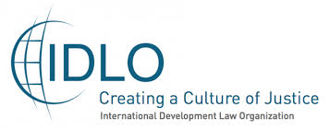

ACCESS TO JUSTICE THROUGH LEGAL AID:
Understanding approaches to Legal Aid in enhancing access to Justice and harnessing the engagement with formal and informal justice systems in dispensing justice.
5th - 8th NOVEMBER 2018, Nairobi, Kenya-SAFARIPARK HOTEL
OVERALL MODERATOR: ARNOLD TSUNGA
DAY 1: Sunday, 4th November 2018

Arrival and Registration
TIME | ACTIVITY
3:00pm–7:00pm | Arrival of participants  Facilitated by: IDLO, NLAS & EAC
7:00pm - 8:30 pm | Dinner
Day 2: Monday, 5th November 2018

8:30 - 9:00 am | Registration
 | Opening Session:Moderated by;Vincent Mutai-Director NLAS Board Kenya.
9.00 – 10.00 am | Opening remarks:  - Chairperson, National Legal Aid Service (NLAS)-Ms. Nazima Malik  - Director, Judicial Training Institute, Kenya (JTI)- Justice Kathurima M’Inoti  - Principal Legal Officer, East African Community Secretariat (EAC)- Ms. Florence Ochago  - Senior Legal Advisor-Program Development-International Development Law Organization (IDLO) – Ted Hill  - East African Judicial Education Committee (EAJEC)- Hon. Justice Dr. Henry Peter Adonyo  Key Note Address: Hon.Paul Kihara Kariuki, The Attorney General of the Republic of Kenya
10.00 – 10.30 am | Overview of the program and brief Introduction to the workshop objectives:  Presentation by: - Dr. K. I. Laibuta
10:30 - 11:15 am | Group photo and Coffee Break
The Session will hereafter break out into the following groups:
- Group 1: Regional Legal Aid Networks
- Group 2: East Africa Judicial Education Committee (EAJEC)

To reconvene on day 4 & 5 for the Joint Forum for Consideration of a Mechanism of Engagement between Formal and Informal Justice Systems.
11:15-12:15pm | Experience sharing by legal aid organizations; lessons learnt, challenges and good practices from East Africa Region  Panelists:Lambert Nsabimana and Christella Kankindi -Burundi, Caroline Amondi NLAS Kenya, Miriam Wachira FIDA-Kenya,Andrews Kananga-United Republic of Rwanda, Sylvia Namubiru-United Republic of Uganda,Felistas Muchi and Christina Kamili-United Republic of Tanzania, Mohamed Abdillahi-Somalia,  Moderator:Eric Mukoya-Executive Director-Legal Resources Foundation
12:15-12:30pm | Plenary
12:30 pm– 2:00pm | Lunch Break
2:00pm –3:00 pm | Experience sharing by legal aid organizations; lessons learnt, challenges and good practices from other Regions  Panelists:Dr. Jerry Makokoane-South Africa, Clifford Msiska-Malawi, Ted Hill-IDLO, Eric Mukoya-Kenya  Moderator:Vincent Mutai-Director, NLAS Board Kenya.
3:00pm-3: 30pm | Plenary
3:30pm – 4:00 | Coffee Break
4:00pm – 4:30 pm | Strategies to overcome challenges in the implementation of legal aid service delivery  Break away Groups:  - Group 1: Mechanisms to promote policy dialogue on regulatory and institutional reforms and funding for legal aid services (State agencies)  - Group 2: Ensuring Effective Legal aid delivery systems and quality legal aid services (Non- State Agencies)  Moderator: Commissioner Jedidah Waruhiu-NLAS board member
DAY 3 | TUESDAY-6th NOVEMBER 2018
9:00-9:50am | Recap-Rapporteur
9:50am- 10:50 am | Group 1: Mechanisms to promote policy dialogue on regulatory and institutional reforms and funding for legal aid services (State agencies)  Moderator:Andrews Kananga, C.E.O. Legal Aid Forum-Rwanda  Presenter: Francis Maina-GJLOS Kenya, Dr.Jerry Makokoane-South Africa(Practicals on delivery systems and quality legal aid services)  Group 2: Ensuring Effective Legal aid delivery systems and quality legal aid services (Non- State Agencies)  Presenter:Clifford Msiska- Director, Paralegal Support Institute-Malawi(Practical aspects of its scope of work; span of work; impact)
10:50-11:10am | Tea break
11:10am–11:40am | Legal Aid in the context of Vulnerable and Special Interest Groups: Challenges and opportunities.  Panelists: Bechir N’Daw-Regional representative-Africa think tank/UNAIDS,  Mr. Saitoti Njenga Saitoti-representing persons with disability  Moderator: Dr.Ruth Aura, Lecturer Egerton University-Kenya
11:40am-12:00pm | Plenary
12:00pm-12:30pm | Presentation of the Kenya National legal aid network needs assessment tool  Objective: (To also inform what is needed at the regional level to see to it that Legal Aid delivery is achieved at both national and regional levels.)  Dr. K.I Laibuta
12:30 - 1:00pm | Plenary
12:30 pm– 2:00pm | Lunch Break
2:00pm-3:00pm | Innovations on various approaches to legal aid delivery and sustainability:  Panelists:Getrude Angote, Kituo cha Sheria-Kenya, Julius MunthaliGovernance expert-Malawi, Sylvia Namubiru C.E.O Uganda Network for Legal Aid Providers, Dr. David Holness Director, University of KwaZulu-Natal Law Clinic (Durban), Mr. Langa Mtshali- National Alliance for the Development of Community Advice-(NADCAO)-South Africa  Moderator: Dr.Okech Owiti, Lecturer University of Nairobi-Kenya
3:00pm – 3:30pm | Plenary
3:30pm – 4:00pm | Coffee Break
4:00pm – 4:30 pm | Group 1: Mapping of way forward on East Africa Regional Legal Aid networks- Focus group discussions  Panelists:Lambert Nsabimana and Christella Kankindi -Burundi, Caroline Amondi, Andrews Kananga-Rwanda, Sylvia Namubiru- Uganda, Felistas Muchi and Christina Kamili-United Republic of Tanzania, Mohamed Abdillahi-Somalia  Group 2: The rest of participants fill the Needs assessment  Facilitator: Dr. K.I Laibuta-Kenya
4:30pm-5:00pm | Plenary
DAY 4: WEDNESDAY 7th November 2018 (COMBINED SESSION)

9.00am -9:45 am | The Role of Legal Aid in Access to Justice  Key Note Speaker:Hon. Mr. Justice Philip N. Waki-Judge of Appeal, Court of Appeal-Kenya  Moderator: - Hon. Justice Dr. Henry Peter Adonyo-EAJEC
9:45am-10:45 am | Comparative and Institutional Frameworks for Legal Aid:  Presenter: Justice Kathurima M’Inoti, Director Judicial Training Institute, Republic of Kenya.  Issues arising from the expansion of Legal Aid in the civil sphere  Presenter: Ted Hill-Senior Legal Advisor-Program Development-IDLO  Moderator:Mr. Edouard Minani,Head, Professional Training Center of Justice, Republic of Burundi
10:45am-11:15 am | Coffee Break
11:15am - 11: 45 | Plenary
11:45 – 12:30pm | Judiciary Experience with Legal Aid:  Panelists:Partner States – EAJEC Members from Partner States  Moderator: Ms. Florence Ochago, Principal Legal Officer, (EAC)
12:30 pm– 2:00pm | Lunch Break
2:00pm –2:30 pm | Judiciary Experience with Legal Aid: (CONTINUED)  Panelists:Partner States – EAJEC Members from Partner States  Moderator: Ms. Florence Ochago, Principal Legal Officer, (EAC)
2:30pm-3: 00pm | Plenary
3:00pm – 4:00 pm | Sharing Experiences on Informal Justice Systems in dispensing justice.  Panelists:  - Hon Justice (Prof) Joel Ngugi, Chairperson - AJS Taskforce - Kenya  - Hon Justice Dr. Benjamin Baak Deng -Justice Baak Deng is a Judge of the Supreme Court of the Republic of South Sudan.  - Dr. Kayihura M. Didas -Dr. Kayihura Is the Director of The Institute of Legal Practice And Development (ILPD) In Rwanda.  - Hon. Justice Ann Williams-JonesDay USA  - Mohamed Abdillah Qablan - Attorney General's Office SOMALIA  Moderator: Hon. Justice Elnaza Luvanda- High Court of Tanzania
4.00 | TEA BREAK AND NETWORKING
DAY 5: Thursday 8th November 2018

9:00am– 10:00 am | Reconceptualising Legal Aid and Access to Justice  Presenter: Dr Okech Owiti – Lecturer University of Nairobi - Kenya  Understanding the Role and Challenges of Legal Aid Networks in Accessing Justice at the Regional level  Presenter: Mr. Paul R. Kaunda-Vice President for Eastern Africa, Pan African Lawyers Union (PALU)  Moderator: Samuel Mohochi- Executive Director ICJ and Chair Paralegal Support Network (PASUNE) Kenya
10:00am- 11:00am | Building linkages for effective legal aid delivery: the role of State and Non- State Agencies  Presenter:Dr. K.I. Laibuta, Dr. Jerry Makokoane-COO-Legal Aid South Africa  Moderator: Dr. Steve Ouma-Deputy Director Research and Policy-JTI.
11:00am- 11:30am | Coffee Break
11:30pm-12.30pm | Presentation of the Resolutions and the Recommendations of the Conference  Presenter: Dr. Steve Ouma-Deputy Director Research and Policy-JTI
12.30 -1.30pm | Closing remarks  - Ms. Florence Ochago, Principal Legal Officer  - Robert Kibor- Vice Chairperson of NLAS  - Romualdo Mavedzenge-Country Director, International Development Law Organization (IDLO)- Kenya  Hon. Justice Dr. Henry Peter Adonyo-EAJEC
1:30pm - 2.30pm | Lunch Break
Afternoon - Networking

DAY 6: Friday 9th November 2018: Departure-check out before 10 a.m.

